**RE Planning Cycle Template**

1. Engage

Bring out the Torah and see if the children can remember what it is. What does it look like? How can we tell that is it special? Does it remind the children of anything? Talk about what it is and compare to the Bible. Explain that this is the story of Gods relationship with the Jewish people. Show a picture of Moses separating the sea, do the children know who he is, any ideas? What do we want to find out about the picture and the person, think about how we can do this? **SEND - Look at the image of Moses together and see if they can suggest ideas who he is and what he is doing and scribe.**

Unit Focus/ Year Groups: Year2 Enquiry 4

**How do Jewish People Celebrate Passover?**

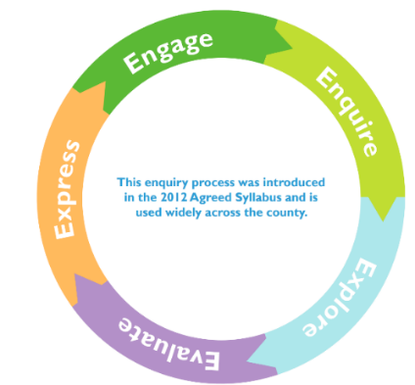

4. Evaluate

Session 1 Show the picture from lesson 1 of Moses, use the same PowerPoint to tell the children the story of crossing the Red Sea. Retell the story using sound e.g. soft and calm for the water and then loud and crashing as it crashes on the Egyptians etc.

Ask ‘I wonder questions’ to help the children engage more deeply with the story. What do you think the Jews might want to say after they have crossed and they are safe? Make 2 lines and can they put some music to it? This links back to usng sound in the retelling and looks forward also to the Song of Miriam below. Emphasis freedom and celebration that they got across. Then share the Song of Miriam which is what is recorded after they have crossed over. The words used in particular are: The Lord is the strength and my song, and He has become my salvation!

e.g https://m.youtube.com/watch?v=m6dq8gLb-MU

How does the children’s words and music compare to Miriam’s?

Sense of freedom and now going to this land that they have been promised. What else does it tell us? Note: This is a difficult story because of the number of people killed in it. Children may say that God is punishing people who don’t listen. Be open to listening to the children’s views and allowing them to ask questions.

Session 2

Set up a table containing Passover artefacts.

Look at the objects on a table and predict what they may be for.

Discuss using talking partners.

Record/video your predictions

What do we know? What do we want to find out?

In this lesson the children are introduced to the table and asked to predict what things might be for. They could also be shown a picture of a Jewish family during Passover to help them raise questions about the rituals and actions, and the meaning of the objects.

Kiddush Cup and wine/grape juice

Kippah

Tallit

Challah Bread x 2 and cover

Seder plate with food items in each segment.

Besimim Box/Spice Box

Menorah Candle

It is suggested that in this lesson the actual rituals of Passover are not shared, but that this is done in lesson 8. The objects themselves will act as stimulus.

5. Express

Set up a table containing Passover artefacts.

Watch the True Tube clip of Passover with Charlie <https://www.truetube.co.uk/resource/charlie-and-blue-celebrate-passover/>

Discuss using talking partners.

Look at the phot and mind map from last session, can they remember the names of the items and what they are used for?

Recreate the Passover meal as a class and share the food items. Children then to create their own Seder plate listing what it contains and why linked to the crossing of the Red Sea.

3. Explore

Session 1: Moses grew up with the Pharaoh as his son. Pharaoh didn’t know that he wasn’t his son. Show the Twinkl powerpoint up to the point where Moses sees the Burning bush (recap and fill in the gaps).

[www.communication4all.co.uk/PowerPoint%20Presentations/Moses.pps](http://www.communication4all.co.uk/PowerPoint%20Presentations/Moses.pps)

Recreate the burning bush using their feet! Put feet into appropriate coloured paint.

Link to idea of taking off shoes as it was ‘holy ground’. While one group are doing the burning bush another group could be writing speech bubbles of what Moses is thinking and what he may be asking himself?

What does this story tell us about Jewish people and the relationship with God?

Key message: God gives his name and commissions Moses to go on a mission. God says, ‘I am who I am I haven’t forgotten my people’ and this led to Moses going on a journey. Jews are reminded that God hadn’t forgot about the suffering.

Show image

<http://4.bp.blogspot.com/-WXOco6qWnW0/Udw2oFwFI/AAAAAAAAPNA/bBjjJ9v7wBM/s1600/2.+Burning+Bush+BV.jpg>

**SEND Continue to share the Moses story.**

Session 2 Use same powerpoint as before to show the story of the ten plagues.

Ask questions about what happened and why. Ask the children to consider what it tells Jewish people about God. Give children sequencing cards and they sequence the story. More able can draw and write the story as a storyboard. Some children may consider which of the plagues was the worst and why. Some children may think about the difference the plagues might make and predict the next part of the story…

The message for Jews is one of freedom and that God chose the Jewish people. They are special and protected. There is also a sense of justice. [**https://www.topmarks.co.uk/judaism/story-of-moses**](https://www.topmarks.co.uk/judaism/story-of-moses)

**SEND -Talk about the ten plagues and recreate them.**

2. Enquire

Briefly explain that in a land called Egypt there were different types of people – Jewish and Egyptians and the leader was the Pharaoh. He was worried that the Jews were going to take over the country so he ordered all the first born sons to be killed. Watch the story of Moses: [www.bbc.co.uk/teach/class-clips-video/religious-studies-ks1-the-jewish-story-of-moses/zmfp382](http://www.bbc.co.uk/teach/class-clips-video/religious-studies-ks1-the-jewish-story-of-moses/zmfp382) Children to work in small groups and use freeze frame to retell the story.

**SEND -Watch the story of Moses on their own chrome book and order some pictures.**