RE Planning Cycle Template
Unit Focus/ Year Groups: Year4 Enquiry 4
Why is there so much diversity of belief within Christianity?
You can use the RE Today exploring diverse Christian worldviews – exploring worldviews Christianity Book
- Engage
Unpack the enquiry question and work out what diversity is? Recap on the philosophy unit (Yr4 En1) where we unpick the difference between truth (Fact), Belief and opinion.

Play a game called ‘Broken Telephone’ (see supplementary notes) with the children. What do they believe the original message was? Use this as a discussion starter into believing what we are told by others. If we only have one source of information, how do we know the truth?

Introduce the concept that the Bible is a source of authority but there are lots of other sources of authority (use diagram in supplementary notes). Christians may use the Bible, but they may also use other sources and that can lead to different people believing different things.

2. Enquire
Use the following website to navigate the demographics of Christianity as a worldwide faith with your class: www.worldatlas.com/articles/christian-denominations-by-the-numbers.html

Watch this video with your class: www.bbc.co.uk/teach/class-clips-video/religious-studies-ks2-what-is-christianity/znshvk7

Ask the children to write a fact shout out for Christianity and ask them why they chose their one. What interested them the most and why?

5. Express
- Produce a guide to a Christian denominational place of worship. In the guide explain the belief and the practices undertaken.
- Provide children with a comparison grid and ask them to choose two or more denominations to identify what is similar and different.
- Provide two characters from different Christian denominations and ask pupils to prepare a short talk as if they were each of the people, explaining their belief as a Christian.
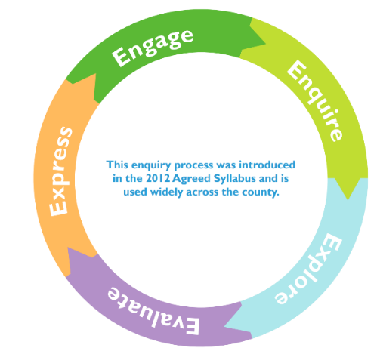

3. Explore
Use the PPT provided to begin to explore the different groups / denominations of Christian’s in the world by:

- Start by watching the embedded YouTube video in the PPT that illustrates the growth of Christianity from the death of Jesus. What do the children notice about the speed of it’s growth? Where had it started? How is expanded around the world?
- Next explore some of the 220,000 denominations around the world and why they believe in different things (teacher knowledge in the supplementary notes will help you with this).
- Next explore how Christian’s look different around the world – that cultural and geographical influences can make us not recognise them as Christians.
- Next look at the population % of Christian’s around the world. What do they notice about where the most Christian’s live – why do they think this is? Where is Christianity less popular – are they surprised by this?
- Finally look at the census data for England and then Norfolk. What do they notice? What is the largest denominational Christian group – why do they think this is?
4. Evaluate
Arrange visits to at least 2 denominations of church in the local area. Identify similarities and differences. Children to explore and answer the set of questions so they are able to describe some of the varying ways in which Christianity is practised locally.

Whilst on your visits you may compare and contrast a festival, rite of passage or worship (e.g. communion) across the two different denominations. Again note what is similar and different.

If you are unable to undertake a visit, then use the following websites to compare Methodist / Catholicism/ Jehovah Witnesses:

www.bbc.co.uk/bitesize/guides/znpbqp3/revision/2
www.bbc.co.uk/teach/class-clips-video/religious-studies-ks2-holy-communion/z7xhy9q
www.bbc.co.uk/religion/religions/witnesses/

Supplementary Notes
The Broken Telephone Game - Broken Telephone is played with a group of children sat in a circle. A word or phrase is whispered into the ear of the first person, who then whispers it into the ear of the next person and so on. The person at the end says the word or phrase out loud to see how close it is to the original.
Sources of authority
TEACHER KNOWLEDGE: Sources of authority - Christian perspectives
The Bible
- The Christian holy book is the Bible and this is the most important source of authority for Christians, as it contains the teachings of God and Jesus Christ.
- All Christians, regardless of denomination, regard the Bible as the starting point for guidance about their faith. It contains 66 different books and is split into the Old Testament and the New Testament.
Old Testament
- The Old Testament is a collection of books that were written before the life of Jesus. It contains the rules which Christians should live by, contained in the Ten Commandments in the book of Exodus.
- The Old Testament also contains examples of:
- other people that Christians can learn from, eg Job
- prayers and songs that are used in worship, eg The Song of Solomon
- passages that are regarded as prophecies of the Messiah, such as Isaiah chapter 53
New Testament
- The New Testament is a collection of books that were written after Jesus died and rose from the dead. It contains the four gospels - Matthew, Mark, Luke and John. It is in the gospels that Christians learn about the example that Jesus set and the teachings that he gave to his disciples and early followers.
- The New Testament also contains the teachings of Saint Paul who helped to form the early church's teachings. He wrote some of the letters, sometimes called epistles, that are in the New Testament, such as Romans and Galatians.
Some Christians also regard the Deuterocanonical books or Apocrypha as part of the Bible. The Deuterocanonical are books that are accepted as scripture by Roman Catholics and the Eastern Churches, but they were not in the Hebrew Canon and are not regarded as canonical by Protestants. These books are usually placed after the Old Testament in a Bible. They help to place other books in historical context and offer a different view on the Hebrew Bible. Examples of Deuterocanonical books include The Book of Wisdom and The Books of Maccabees.

Other important Christian sources of authority

The apostles
In early Christianity, the apostles had a special place of honour. After the apostles had visited a town, they would lay their hands on certain leading Christians and appoint them to act in the place of the apostles.
According to many Christian churches, notably the Roman Catholic, Orthodox and Anglican Churches, these Apostles were the first bishops. Bishops guide their communities and tell them how to interpret the Bible in modern situations. They are seen as the descendants of the apostles.
Because bishops are responsible for large areas (diocese), local ministers are appointed to care for the immediate concerns of the community. These are often called priests, vicars or pastors. They have studied the Bible in depth and can interpret its teachings. Ministers are able to offer the community advice and guidance based on the teachings of the Bible.
The Roman Catholic Church is led by the Pope who is based at the Vatican in Rome. The Pope is considered to be the direct successor of St Peter, the leader of the apostles.

Tradition
Many Christians also rely on tradition for guidance. The Christian Church has existed for two thousand years and many traditions and practices have developed over the years which people find reliable and helpful. Tradition must be supported and reinforced by the teachings in the Bible.

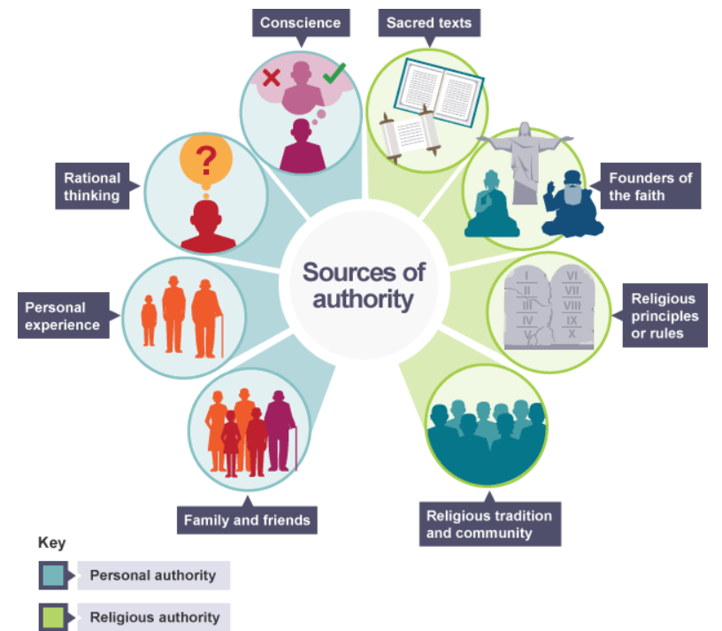

Christian Denominations – Teacher Knowledge use this website: www.thegospelcoalition.org/blogs/trevin-wax/quick-guide-christian-denominations/

PPT – Christian Denominations from around the world
