**Bishop’s Lent Appeal 2024**

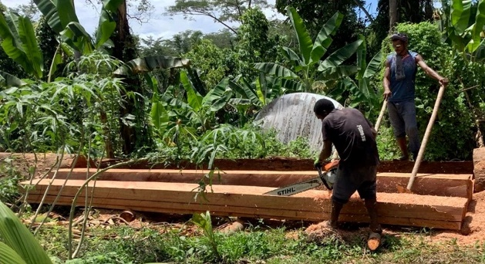A huge thank you to all the parishes and individuals in the diocese who supported the Bishop’s Lent Appeal this year. We are now able to announce the total amount raised is £10,240 which will enable us to fund around 25 water tanks for the students and their families at the Modawa Institute outside Popondetta in Papua New Guinea. Previously known as Newton Theological College, the new institute will now include male and female students studying theology, nursing and teaching. The Modawa tree has come to represent the growth of the church in PNG, which from its earliest days included healthcare and teaching alongside the training of priests.

Theological training in PNG looks slightly different to that in the UK – single or married they live on site with their families, where afternoons are free from lessons for tending to the food gardens and doing site maintenance. This can include anything from washing the college car to cutting and milling trees for new classrooms.

There has been a mammoth effort to repair and replace dilapidated college buildings. Ensuring the water supply for students and staff continues to be an ongoing challenge with increasing drought and then downpours leading to flooding. Most washing – body, clothes and dishes is done in the local river. Drilling a campus bore-hole will help but so will the water tanks providing a continuous supply of water to dormitories and houses.

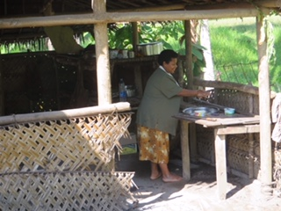Thank you again for supporting our work in supporting the church in Papua New Guinea.

We would ask you to continue to pray for the students and their families, knowing that, on a weekly basis, they face challenges of health, finding enough food, clothing themselves and their families.

Would you like to commit to support the growth of the church in Papua New Guinea? Is your church looking for a mission project? Your church or your fellowship group could -

* invest in the lifelong ministry of a priest and his wife through provision of a student scholarship (£500 pa for three years)
* provide a small living allowance for a family (£40 monthly)
* Provide a small living allowance for a single student (£25 monthly)

Details of these can be found on the Modawa Institute website - modawa.institute/what-can-i-do

Other news and information on the church in Papua New Guinea can be found on the Papua New Guinea Church Partnership website - www.pngcp.org.uk