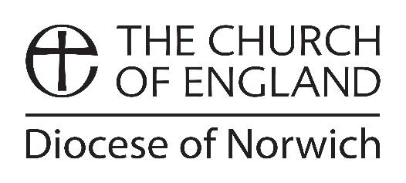

**Clergy Adoption Leave and Pay Request Form**

Please read through Clergy Adoption Leave and Pay Policy to check that you qualify. You must advise your Archdeacon/DDO, the NDBF HR Manager and Finance Officer in writing, by completing this form and sending it to them, 35 days before the expected placement date. If there are reasons why this is not possible, provide notice as soon as is reasonably practical.

|  |  |  |  |
| --- | --- | --- | --- |
| **Full Name:** |  | | |
| **Office held:** |  | | |
| **Home Address** |  | | |
| **Full-time / Part-time** |  | | |
| **I wish to formally advise the Diocese of Norwich that I am adopting a child.** | | | |
| Expected date of placement: | |  | |
| I intend to commence my Adoption Leave on: | |  | |
| I intend to return to office following the adoption and my anticipated return to work date is: | |  | |
| In order to receive adoption leave and pay you are required to provide us with a Matching Certificate from the adoption agency confirming:   * The agency’s name and address. * The name and date of birth of the child. * The date you were notified of the match.   Please tick relevant box below: | | | |
| Matching Certificate is attached | |  | |
| Matching Certificate to follow | |  | |
| Overseas Adoption | | | |
| If you adopt a child from overseas you must have received notification that the adoption has been approved by the relevant UK authority (Official Notification). | | | |
| The date you received Official Notification: | |  | |
| The date the child is expected to arrive in Great Britain: | |  | |
| Official Notification is attached: | |  | |
| Official Notification to follow: | |  | |
| Any other information/questions please state below: | | | |
|  | | | |
| Signature: | | |  |
| Date: | | |  |