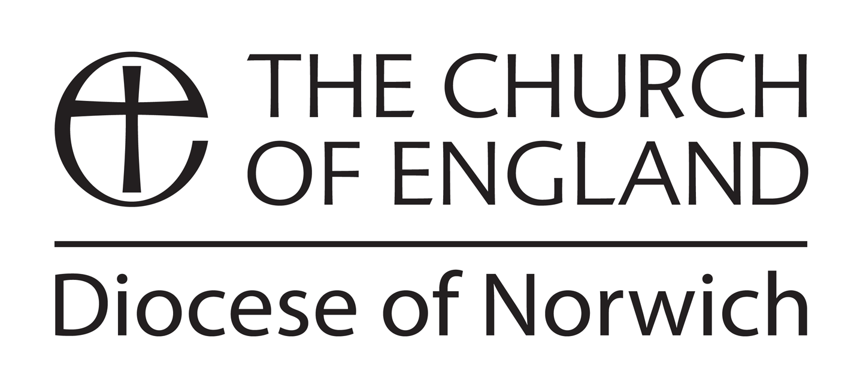
Continuing Ministerial Development
for Licensed Lay Ministers
Grant Application Form

Please read the Guidelines on the website before completing this form

If completing this by hand, please print name and contact details. If you are completing this form electronically, the boxes will expand as you type.

Name and date of birth of applicant:

Address:

Email address:

Evening telephone number:
I would like to apply for £…………… for the following (course/event/book/library subscription):
(Total cost of course/event/book etc £……………………)
Title of course/book/event:

Date of course or event:

Please provide documents to support your claim – eg a booking form for a course or conference. State here which documents you are attaching.

In terms of your development, please say how you think this will assist you.

Have you applied for any other grants for this activity? If so please specify to whom and the outcome of your application(s).
Name and telephone number of your incumbent/minister

To be completed by your incumbent

Please comment on the work undertaken by your Licensed Lay Minister and indicate how you expect the activity for which this grant is claimed to benefit their ongoing ministry and development.

I have discussed this continuing ministerial development (CMD) activity with the applicant and agree it would be of benefit to their work as a licensed lay minister.

Date…………………… Signed (Incumbent)………………………………………………

If you would prefer to receive your grant by BACS (direct transfer from the diocesan account into your bank account), please give your bank account details

Bank Account details for BACS transfer:

Bank:
Account Name:
Sort Code:
Account Number:

Signed (LLM)…………………………………………………………………………………

Please return this form to:

Alan Cossey

Email: alan.cossey@dioceseofnorwich.org

