
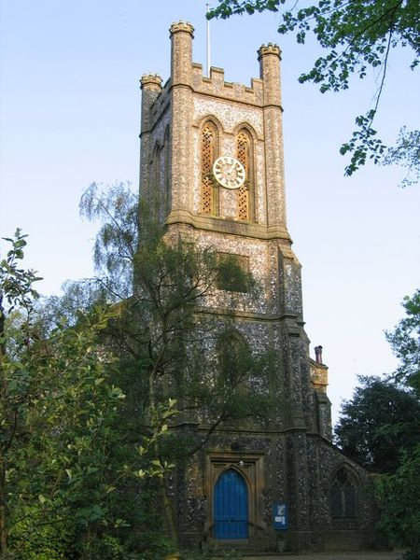
Lakenham St. Mark
PARISH PROFILE
January 2025
“I first discovered St. Mark’s on a summer day several years before I became the thirteenth vicar. I had driven into Norwich from my country parishes ….... and had experienced difficulty in locating the church, so it was with some relief that I finally climbed the steps to the west door and with amazement that I entered and experienced for the first time the atmosphere of prayer, worship and devotion of which in my experience at least, the interior of St. Mark’s speaks so powerfully. St. Mark’s though young by Norwich church standards has, in the past 150 years, established itself as a house of prayer where weary souls may take refuge and find peace, where the great mystery of the love and sacrifice of God is regularly celebrated and represented in the Holy Eucharist and where the broken spirit may find healing and reassurance. The atmosphere of the building is a direct result of the way it is used and the people who use it.” | 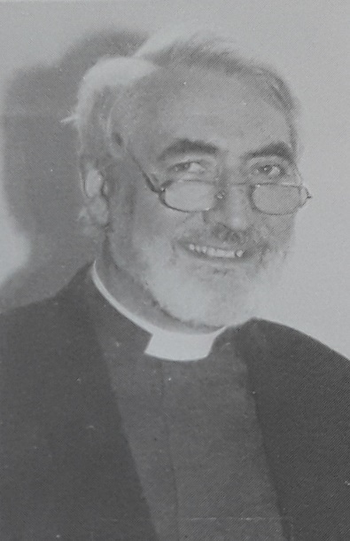  JOHN LAKE WILSON  Thirteenth vicar  of St. Mark’s,  from 1985 - 1999  (Extract from the Foreword to “One Hundred and Fifty Years of St. Mark’s Lakenham” published in 1994.)
Contents
Our Vision; Tasks; Person; What we offer  Welcome from our Churchwarden  Our Vision and our new Vicar  Our Diocese and Deanery  Our local area: the Parish of St. Mark  Our ministry team, staff, volunteers and PCC  How we worship  Fellowship in church life  Outreach and wider ministry  Our church and church hall  The Vicarage  Finances  Safeguarding, Racial Justice and Inclusion  Living and working in Norwich and Norfolk  APPENDICES:  (1) Parish boundary, statistics & demographics  (2) Annual Report 2024  (3) Parish Accounts for 2023  (4) Safeguarding Policy |  | Page 2  Page 3  Page 4  Page 5  Page 6  Page 7  Page 9  Page 10  Page 11  Page 12  Page 14  Page 15  Page 16  Page 17  Page 18  Page 20  Page 22  Page 24
Further information & getting in touch |  | Page 25

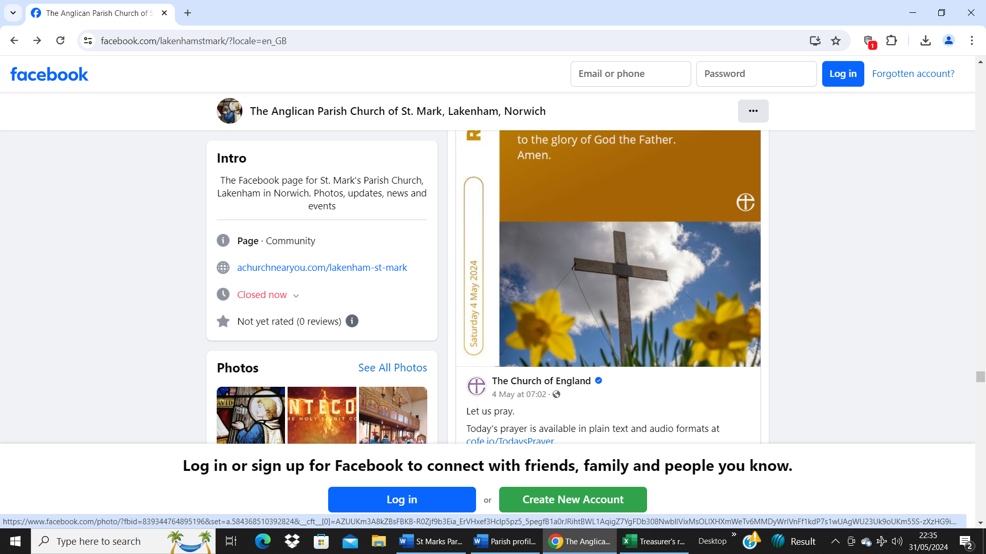
x- 1 –
Our Vision; Tasks; Person; What we offer

Our Vision:
To strengthen our faith that we may reflect the light of Jesus Christ to the community around us.
Tasks:
- To embrace our Liberal Catholic Church tradition, whilst being open to new forms of worship.
- To maintain the welcoming and inclusive atmosphere of St Mark’s.
- To nurture the gifts of our congregation and encourage our dedicated volunteers.
- To grow our ministry to children, young people and families.
- To maintain and develop links with local schools and uniformed groups.
- Develop new initiatives in outreach and mission – in conjunction with the churchwarden(s) and PCC.
Person:
- A person who is prayerful, rooted in scripture and the sacraments and open to all.
- A good pastor.
- An able communicator with experience of working with children, young people and families.
- A person committed to collaborative working with clergy and laity.
- An approachable, visible and energetic presence in the parish who does not take themselves too seriously.
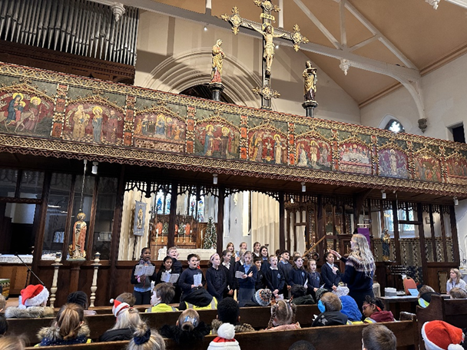
What we offer:
- A welcoming and supportive congregation with a committed & dedicated PCC.
- A well-maintained church building and hall with no outstanding works to do.
- The financial means to develop new initiatives.
- Expenses to be paid in full.
Lakenham Primary School carol service
- 2 -
Welcome from our Churchwarden

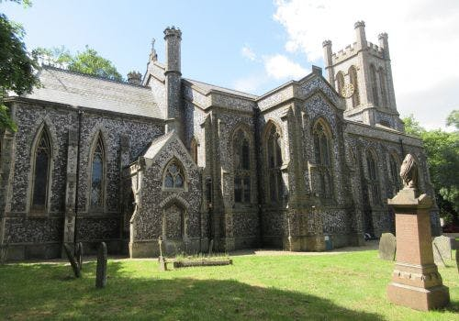
Thank you for taking the time
to consider becoming our vicar.
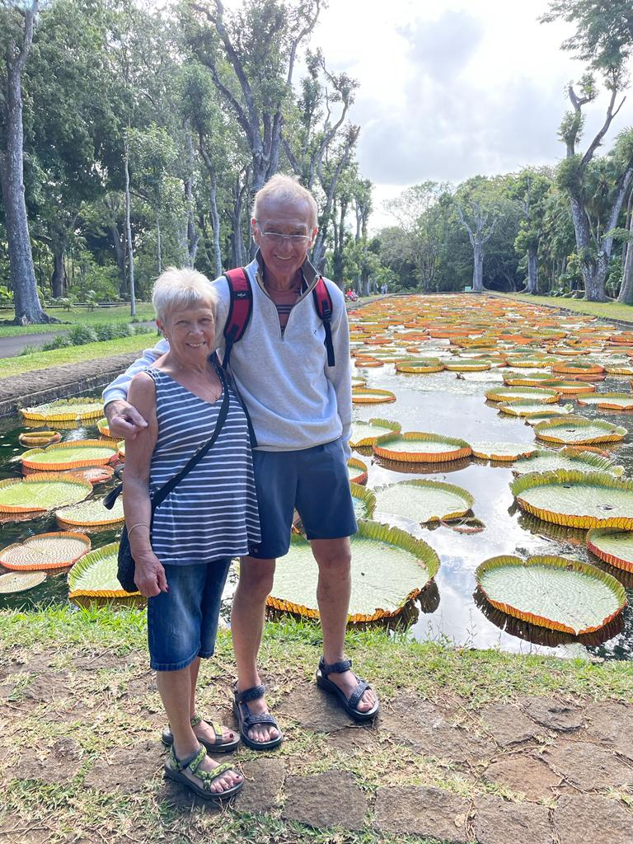
We’re really very grateful for your interest in our vacancy. Indeed, we’d love to have the chance to tell you more about what we have to offer and also to hear what you think you can offer us.

John Wilson’s words above say much about the nature of our local community, the community to which our three most recent incumbents have been happy to devote a total of over 50 years of dedicated service. Circumstances change though; new challenges confront us, and so we must adapt and respond accordingly.

Now, with the retirement of our current vicar Erik, we need perhaps to take stock. We have an opportunity for reflection and reassessment; a chance to chart our course into the middle of the twenty first century. This process of renewal represents a spiritual journey, our quest at this stage being to find somebody to help define the route and lead us along the way. Clearly, we shall continue to face threats and challenges. Equally though, there are also exciting opportunities for the right person to excel. We hope that you feel moved to consider joining us, and that this Profile will help to convince you accordingly.

Helen Wilkinson
- 3 –
Our Vision and our new Vicar

Our Vision is:
To strengthen our faith that we may reflect the light of Jesus Christ to the community around us.

We would therefore hope that when our new vicar is appointed, they will be able to lead with enthusiasm the development and growth of our church family and fulfil that mission.

We have the building and we have a small but dedicated and devoted group of volunteers ready to support whoever is appointed and whilst our tradition has been primarily "high church" we are open to change and happy to embrace new ideas.

As an all-inclusive church we feel that we offer an excellent opportunity for a dedicated and enthusiastic vicar to lead us and to fulfil their own mission and calling, whether that be a person who is recently ordained or someone looking for a new opportunity to adopt a new challenge.

With the long-standing support from parishioners for all events and special services at St. Mark’s, together with the outreach activities already achieved with Hall users, the potential for further outreach and growth is enormous.

A lot of information is included in this profile but if you wish for more detail, would like to have a general chat, or even arrange a visit, please contact Helen our churchwarden.

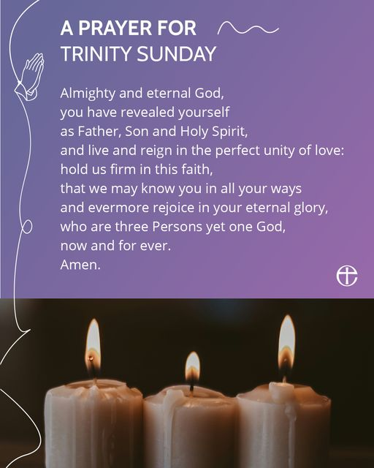

- 4 -
Our Diocese and Deanery

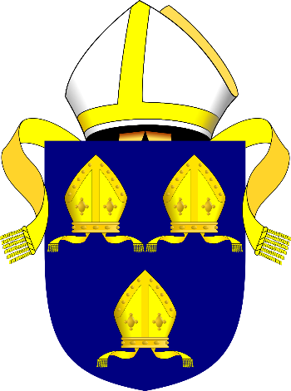
The Diocese of Norwich

The Diocese of Norwich was formerly known as the Diocese of the East Angles, East Anglia, Elmham, and Thetford, and forms part of the Province of Canterbury.

The Diocese traces its roots in an unbroken line to the diocese of the Bishop of the East Angles founded in 630. In common with many Anglo-Saxon bishoprics it moved, in this case to Elmham in 673. After the Norman invasion, it moved to Thetford in 1070, then to Norwich in 1094.

It covers 573 parishes with 656 churches and 110 Church of England schools covering all of the county of Norfolk save for the extreme west beyond the River Great Ouse that is part of the Diocese of Ely. It includes the deanery of Lothingland (the port of Lowestoft and its immediate hinterland) in Suffolk. This totals an area over 1,800 square miles (4,700 square kilometres) with a population (2008) of some 867,000.

Like most older dioceses, the territory has been gradually reduced. Until the formation of the Diocese of St. Edmundsbury and Ipswich in 1914, Suffolk was included, and earlier other areas.

The Diocese of Norwich includes the Archdeaconries of Lynn, Norfolk and Norwich..

The Norwich (East) Deanery

The Norwich (East) Deanery is one of 20 in the Norwich Diocese. It embraces 18 benefices, 17 parishes and 20 churches from central Norwich in the west to Thorpe End in the east and Trowse in the south. The full list of parishes is set out below:

- Norwich St George Colegate  - Norwich St George Tombland  - Norwich Heartsease  - Lakenham St Mark  - Norwich Lakenham St John  - Tuckswood  - Norwich Cathedral  - Norwich St Andrew  - Norwich St Giles | - Norwich St Helen  - Norwich St Peter Mancroft  - Norwich St Stephen  - Thorpe End  - Norwich Thorpe Hamlet  - Thorpe Episcopi  - Norwich St John Timberhill  - Norwich Trowse



- 5 -
Our local area: the Parish of St. Mark

St Mark’s parish lies between Norwich city centre to the north-west and the ring road and river to the south-east. As can be seen from the map in the appendix, the church sits between the two main roads which run north / south.  To the west and north of the church the area is populated mainly by council flats with some social issues normally associated with similar inner-city communities.  To the east and south lie several streets of owner-occupied houses, both terraced properties and larger detached houses. Norfolk County Council offices at County Hall and their extensive grounds are within the parish boundary.  The two schools, two residential care homes, several shops, take-away food shops, three pubs, cafes and charity shops meet most of the community's needs in addition to the city centre shops which are only 15 minutes' walk from the church.  Because of our location and the large number of social housing properties, there has been a steady growth in residents of different nationalities with their own traditions and beliefs but happily the community lives in harmony together. | 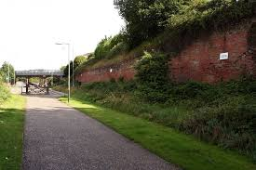  Lakenham Way, is an attractive footpath and cycleway running through Lakenham between Sandy Lane and Brazengate on the edge of the city centre. It was created in the late 1990s and follows the route of an old railway line. There are impressive brick railway structures and wildlife to be seen.  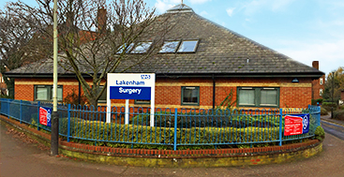  Lakenham Surgery is in Ninham Street. The GP practice / organisation / PCN is part of the Waveney Integrated Care System. The surgery has five doctors, a nurse practitioner, four nurses, two healthcare assistants and a support staff of 15.  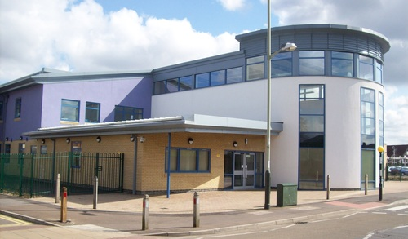  Lakenham Primary and Nursery School on City Road is a multicultural two form entry primary school. that comes under the Norwich Co-operative Learning Trust. With a motto of “Enjoy, Aspire, Achieve”, it has a capacity of 420 pupils.
- 6 –
Our ministry team, staff, volunteers & PCC

Our Ministry Team  Our ministry team has been led since 1999 by our retiring vicar, supported more recently by Paulette Yallop, Licensed Lay Minister with Permission to Officiate. She has been fulfilling this role for several years and continues to support the vicar and serve the parish with dedication and empathy to people's individual needs and the church's wider outreach. A long-standing member of the church and PCC, she acts as secretary taking and keeping the minutes and documentation up to date. Paulette is one of the regular helpers at Little Lions, Open Church, coffee mornings etc.  Staff volunteers and PCC  We currently have only one Church Warden supported by four PCC members, all long-standing worshippers at St Mark’s contributing over 150 years dedication and experience.  Helen Wilkinson has been our Churchwarden for two years; she has worshipped at St Mark’s for over 40 years and has a lifetime history helping and caring for others in her nursing career and socially through fostering, victim support, organizing and taking aid to Romania and many similar activities. She brings boundless enthusiasm and love for St. Mark’s, fulfilling her Churchwarden duties managing the church hall and running the thriving Knit and Natter group. Several years ago when we had the demand she helped run the Sunday School, Youth Fellowship and Young Wives. | 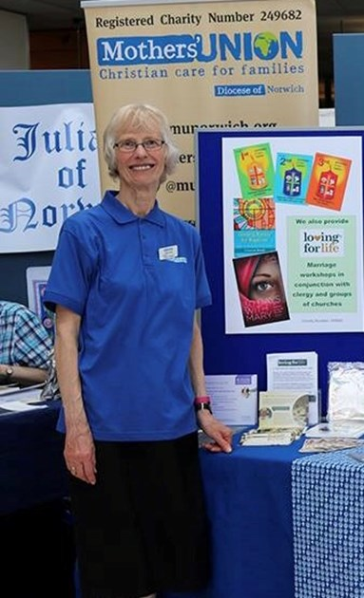  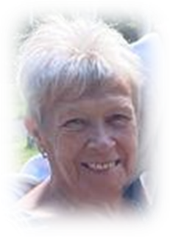

- 7 –

Peter Phillips has also been a member of the St. Mark’s family for many years having been PCC treasurer for over 10 years, and being responsible for successful funding grant applications for the roof repairs and the tower repairs. Peter is a member of our small choir, and a helper at Litle Lions, Open Church, coffee mornings and all activities in the church life.  Marguerite Phillips, Peter’s wife, has likewise been actively involved with our church over the same period. She also sings with the choir, helps at Little Lions, etc., and is active with the Mothers’ Union. As a member of the PCC she holds the role of Parish Safeguarding Officer, a position she embraces diligently and with much enthusiasm.  David Archer has acted as server during services for several years and, as well as serving on the PCC, completes many of the small ‘behind the scenes’ duties that often go unseen but without which the church would not function as smoothly as it does.  Chris Southwell has been a dedicated and hard-working member of the St. Mark’s family for almost 50 years. He has considerable experience as a member of the PCC having served lengthy spells as Churchwarden managing a complex range of challenges. Chris continues to provide valuable help and support to current Churchwarden, Helen, in dealing with routine maintenance and administrative tasks.  St Mark’s and the church family feel privileged to have this small but dedicated team taking care of us and working for the parish and its future. | 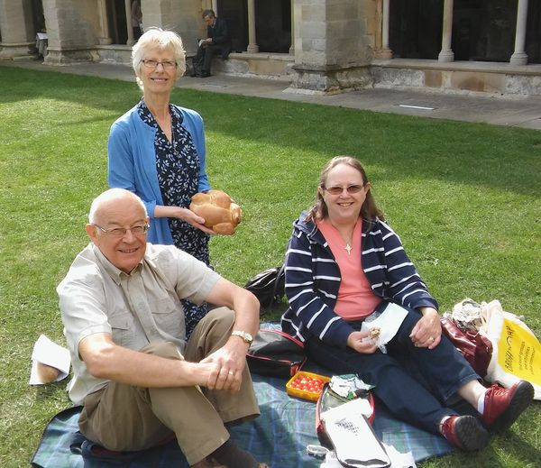  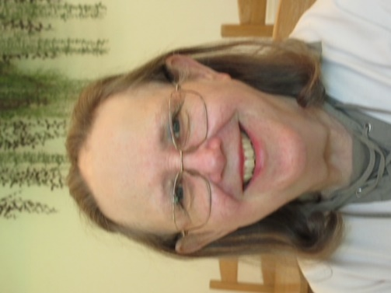  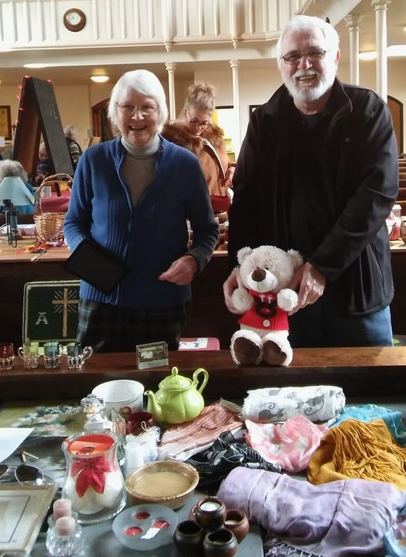  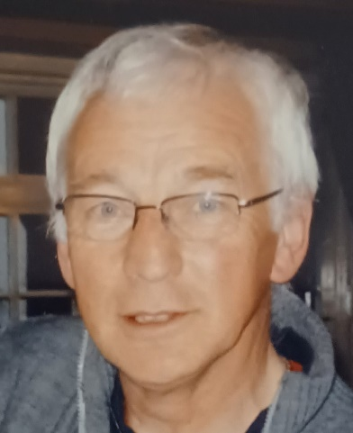

- 8 -
How we worship

Since being consecrated on September 24th 1844, St Mark’s has enjoyed and shared decades of worship, faithfulness and reverence. Sacramental worship is still conducted with ceremony, colour, incense and tradition We meet together every Sunday morning in worship and fellowship and celebrate the great days in the church calendar.

Whilst Sunday service congregation numbers vary from 15 to 25 most weeks - with more on special occasions - the most ‘popular’ service is the Christmas Eve carol service when between 120 and 160 adults and young children alike enjoy a mixture of carols, prayers and share the Christmas story; all delivered in a family-friendly pantomime atmosphere.

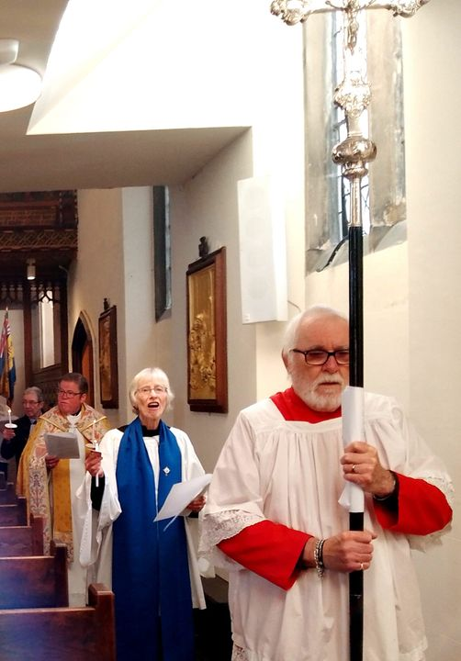

- 9 –
Fellowship in church life

Although the make-up of St Mark’s church family has changed over the years, and we currently do not run a Sunday school or youth fellowship, we do run some well-supported and popular activities.  Little Lions parent and toddlers meet every Wednesday in the church hall with a paid qualified leader supported by church members, providing opportunities for outreach with the parents and carers who are not regular attenders at services.  The Knit and Natter ladies’ group meets alternate Thursday afternoons and has become a very popular, warm and welcoming social group especially for several older ladies who live alone. It should be noted that some ladies come to enjoy Helen’s cakes!  St. Mark’s Mothers’ Union has had a presence for over 100 years. The members currently support national and diocesan events/campaigns.  Every Wednesday morning from 10 am until 1 pm we hold Open church offering a warm welcome with tea/coffee and cakes in an informal atmosphere. Visitors include regulars who enjoy the company and refreshments, others needing quiet space and contemplation, and some who come for the rich history and architecture of the church. The number of visitors varies from as few as 5 up to 20. Other occasional activities and events are held and have included Saturday coffee mornings, traditional church fetes and special events such as a Crib festival and Christmas tree festival. | 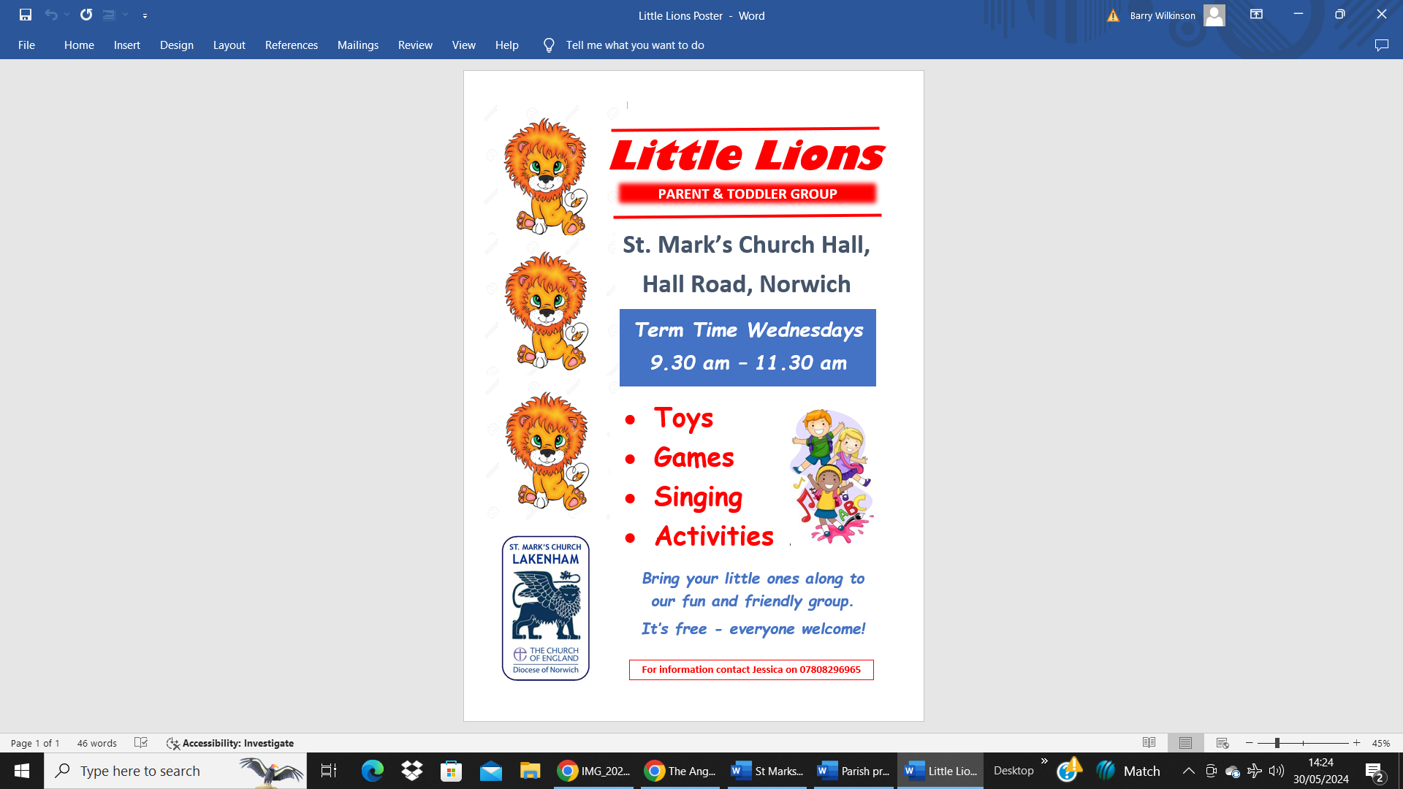  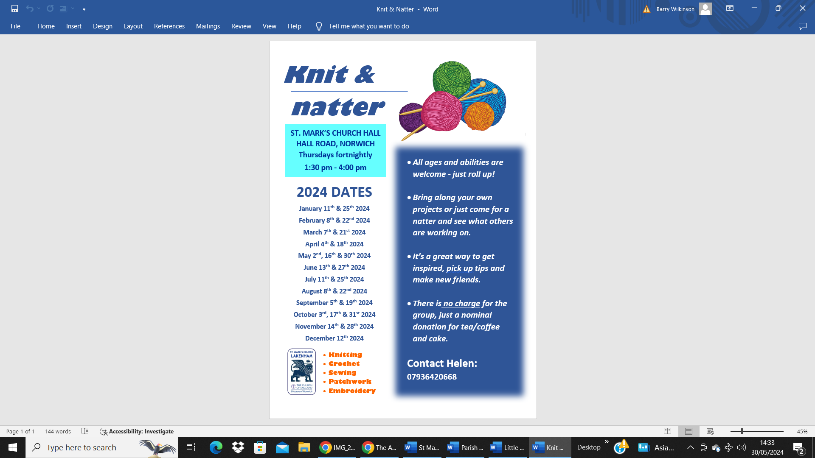
We have held some special occasion celebrations including the centenary of the rood screen, and the special anniversaries in the church buildings’ life. Major events were held over several days remembering the anniversary of the 1942 blitz on Norwich involving the local schools, an in-church street party for the elderly members of the parish; and secondly marking the end of the First World War with a poignant tribute to the 190+ men remembered on our war memorial.

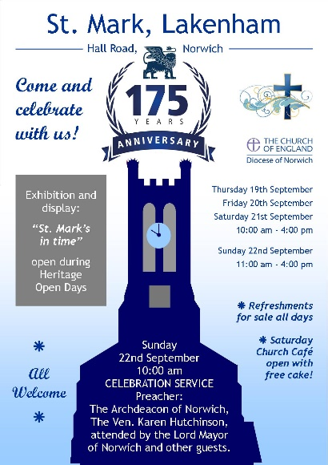 | 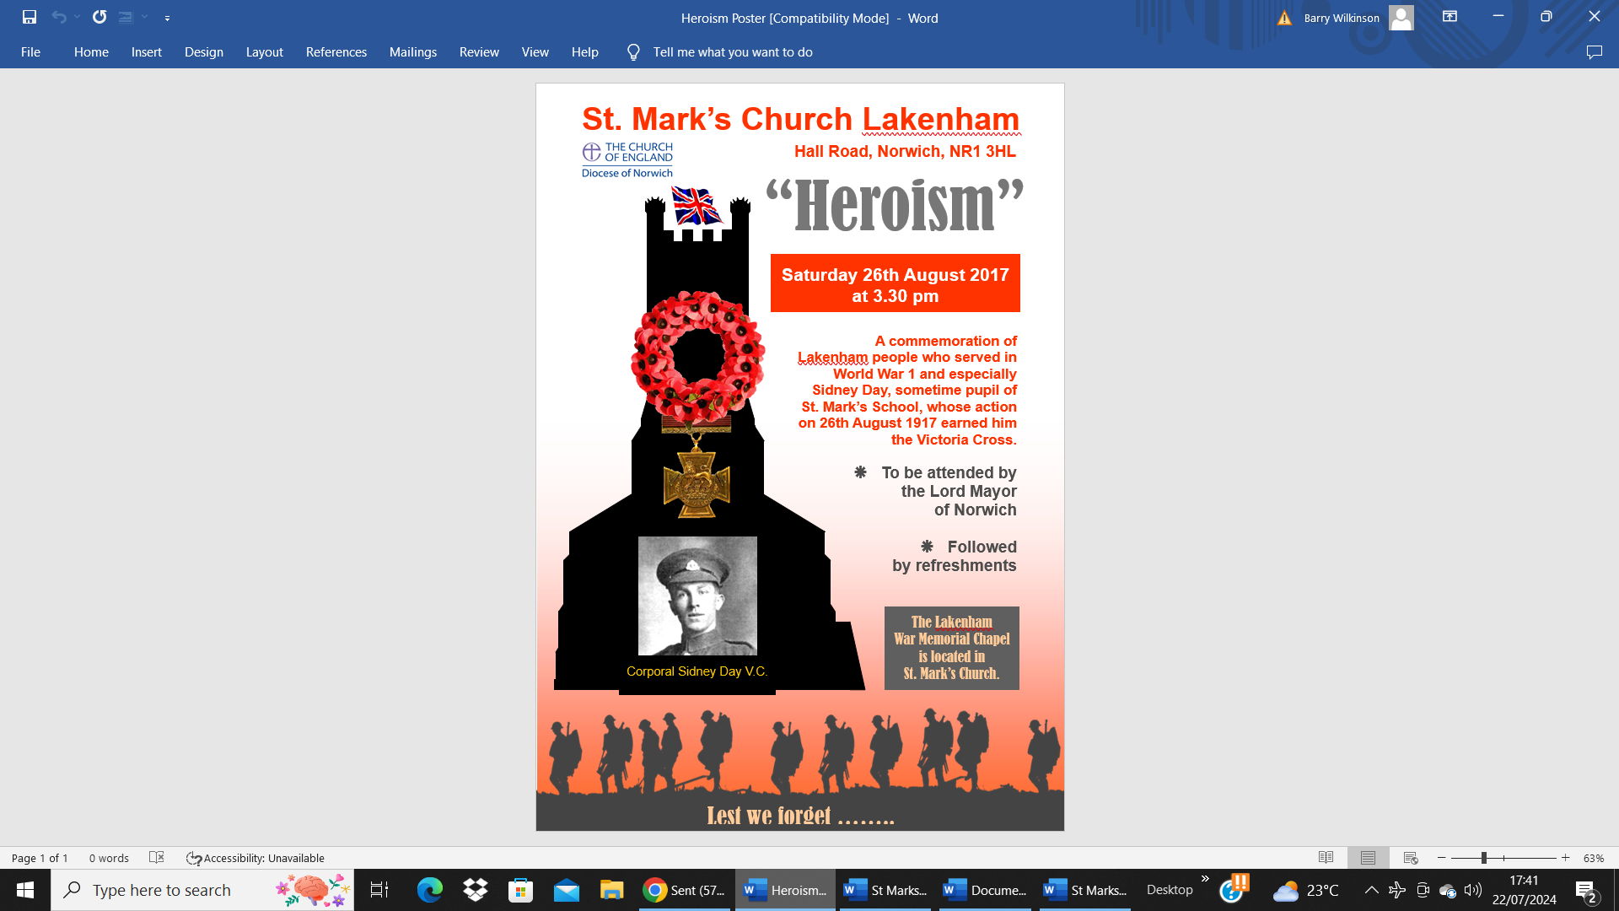 | 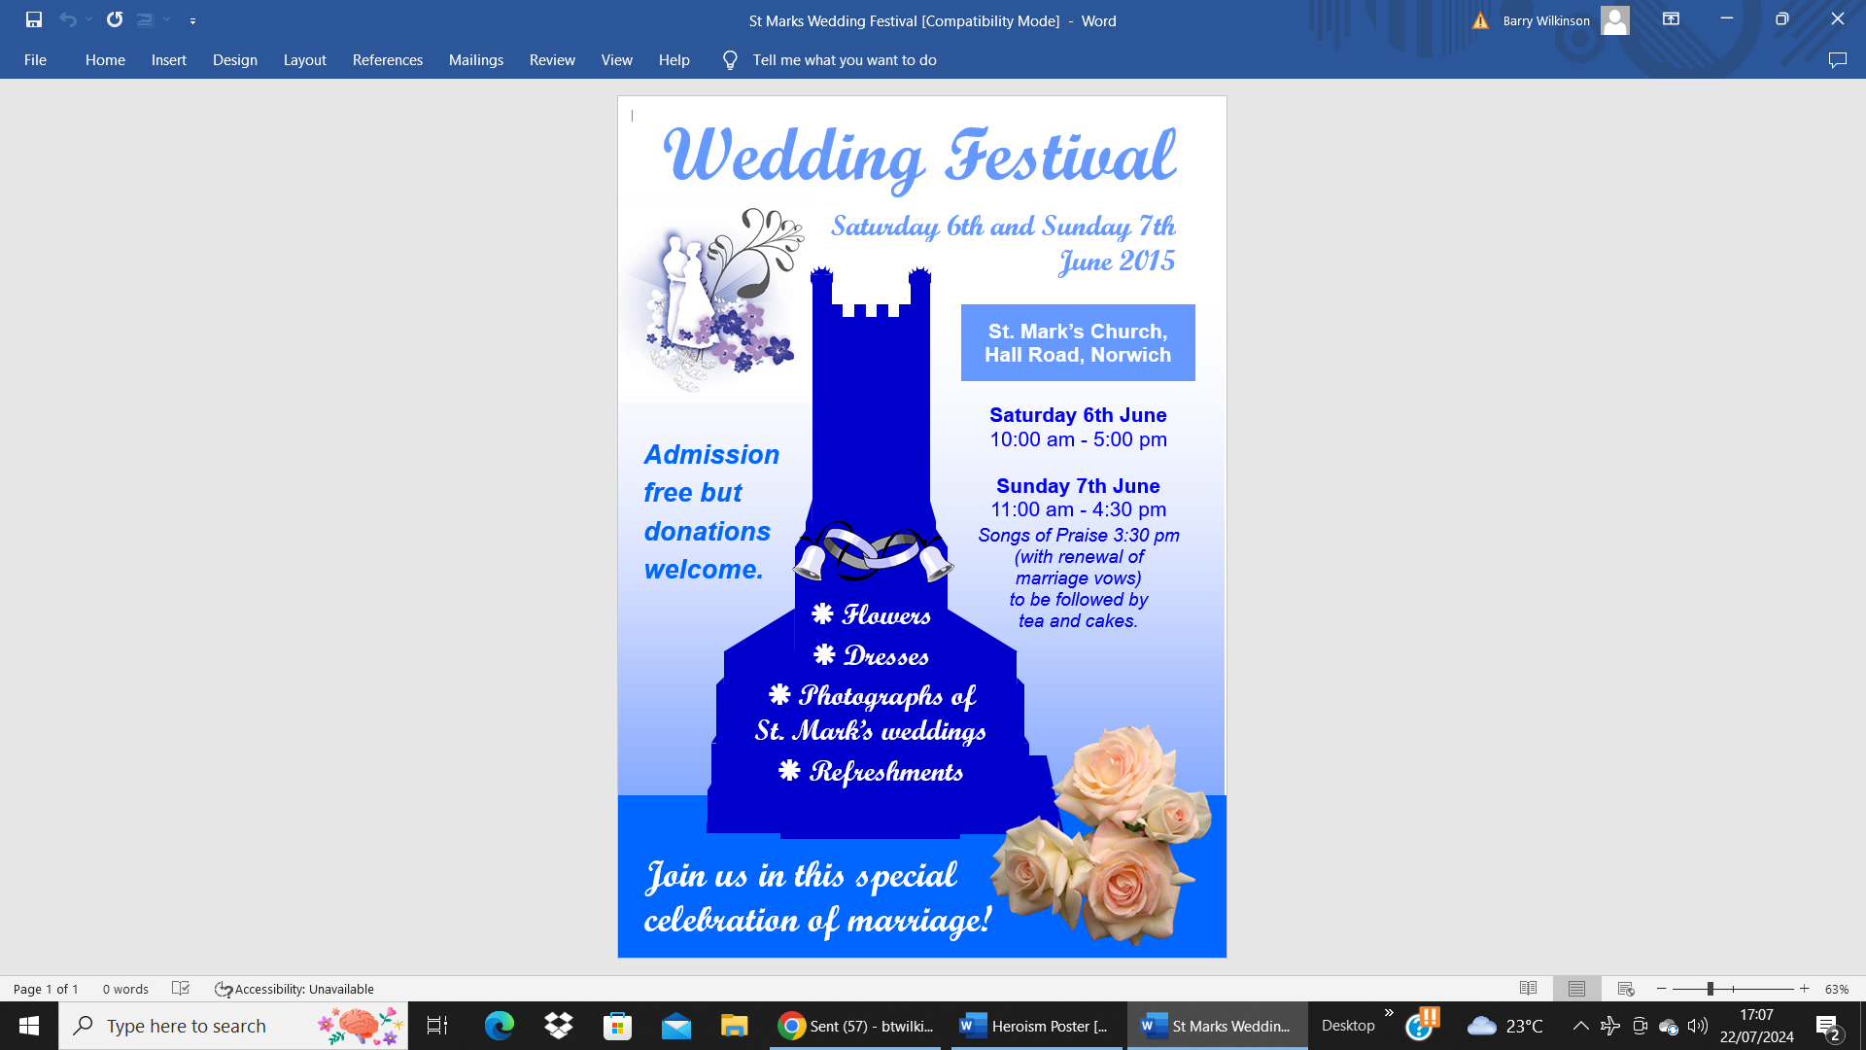

- 10 -
Outreach and wider ministry

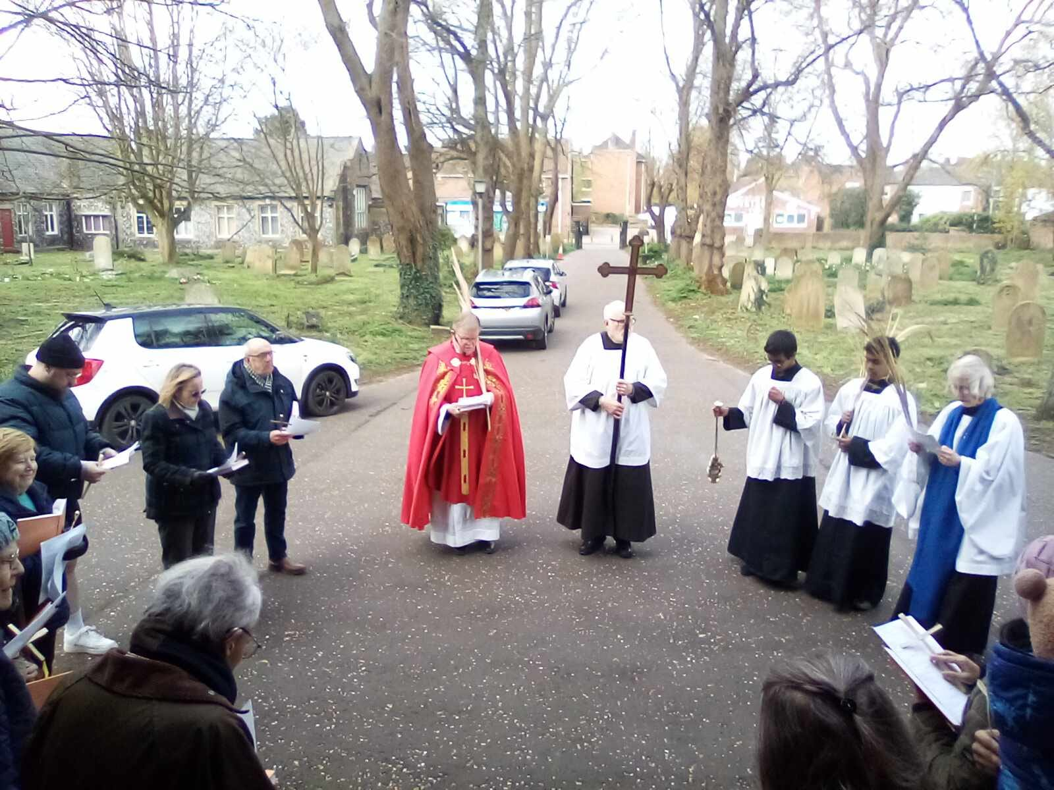

The majority of our current outreach is through activities within the church such as the Open Church, Little Lions, Knit and Natter and Christmas events.

In recent years a few of the local churches have come together on Good Friday to process with the cross through the parishes to finish at St Mark’s with the stations of the cross, although for various reasons this year we did this on our own.
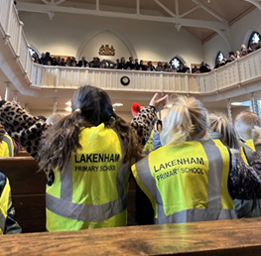 | There are two schools in the parish, the local authority Lakenham Primary and Nursery School and the private Steiner School. The Steiner School has not yet joined us in any church events, but our churchwarden is building a friendly relationship with making use of the hall available for meetings and a fund-raising sale. Our retiring vicar led assembly at the primary school for several years. The school comes to St Mark’s every Christmas for their own carol services, one for Early Years and KS1 and one for KS2. Over two services the pupils and family members bring over 700 people fill the church, including the gallery, as can be seen (left).
There are two residential homes in the parish. Harriet Court is located at Lakenfields close to County Hall, and Corton House is on the east side of Hall Road directly opposite St. Mark’s Church. Some links with Corton House residents have been fostered in the past through worship and home visits, but this has been less the case with Harriet Court.

We hire out the church hall for such diverse activities as the Bracondale Residents’ Association, local Asian residents (many Aviva employees) for family parties, and recently the Girl Guides who have moved to us from St. Albans.

- 11 –
Our church and church hall

The Church: The church building is in an excellent condition due to major works being completed in the last 15 years, thanks to two substantial grants from English Heritage, the Lottery Fund and some individual legacies.  The church roof was replaced between 2008 and 2010 and the church decorated when the work was completed. The church organ was taken out and cleaned and refurbished by a specialist company, and whilst this work was in progress services were held in the church hall. New toilets and a small kitchen were installed.  A further grant was obtained from the Heritage Lottery Fund to pay for remedial work to the tower and buttresses with this all being completed in 2018. | 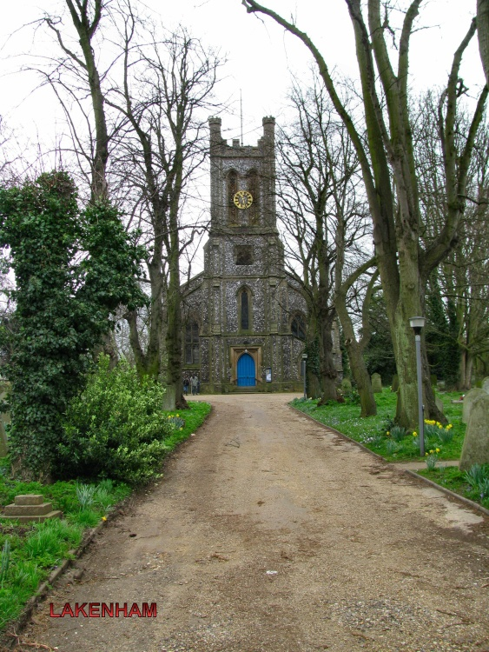
With the fabric safe and sound, smaller improvements were undertaken including wall boards on the balcony for display material relating to the history of the parish and current activities. The memorial chapel was cleaned and refurbished. New security lights have been installed outside, and a much-improved lighting system has been installed inside the church itself.
A new ramp was installed outside the South door and new hand rails installed on all stairways.
All in all, our church is in a sound state but the PCC are looking to replace the heating system which will then necessitate the walls being repainted, and then the long overdue replacement of the carpeting throughout will set the immediate future of the church in good stead.

The Church Hall: Situated on the western Hall Road frontage of the church site, the church hall is based in buildings originally used as one of three St. Mark’s church schools. Parts of the premises are let on long-term tenancies but the spacious main hall (with stage and proscenium arch), separate meeting room, and kitchen are available for community uses that include fitness/sport, Yoga and exercise classes, drama groups, business meetings, slimming clubs, Girl Guides and a mother and toddler group.
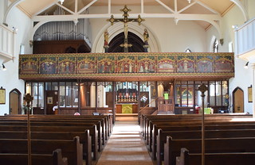  Main church nave and rood screen | 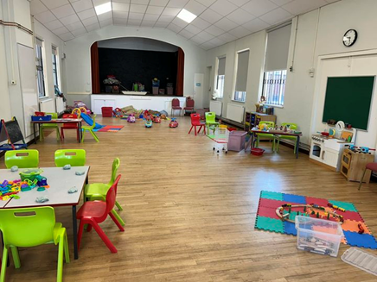  Church hall ready for Little Lions

- 12 -
Church history and main features  The Church of St. Mark Lakenham was an early work of the Diocesan Architect John Brown. Built in the 1840s when the first great wave of the Anglican revival was just beginning to make its way from Oxford, its style, although ostensibly Perpendicular, is largely pre-Ecclesiological. The apse and vestry, also by Brown, were added in 1864.  The 1840s gallery, which goes around three walls of the nave, still has its box pews as if this was a non-conformist chapel. They have survived despite regular suggestions to remove them over the last 150 years.  Around the walls of the nave, the alabaster Stations of the Cross - deep reliefs in an Italian Renaissance style - were donated by the Bignold family and dedicated in 1934. They are the work of the Kilburn Sisters.  Without a doubt, the most important feature of the interior is the rood loft and screen. It was installed in 1910 to the designs of George Bodley who had died three years earlier, and then painted in 1913 to the designs of the architect and artist Temple Moore. It is painted in a rich, late medieval style, with Art Nouveau qualities, and depicts the Christ story from the Annunciation to the Day of Pentecost.  The vestry retains the only 19th Century window in the church depicting Samuel and David beneath a descending dove and remembering two choirboys drowned on an outing in the 1860s. One famous choirboy from a later era (and a former pupil of St. Mark’s School) was Sidney James Day who was awarded the Victoria Cross following his heroism during World War 1.  Memorials to local members of the armed forces who fell during the First and Second World Wars are located in the St. George’s Chapel. There is an outside war memorial to the south of the church in the graveyard which also contains a single Commonwealth War Grave.  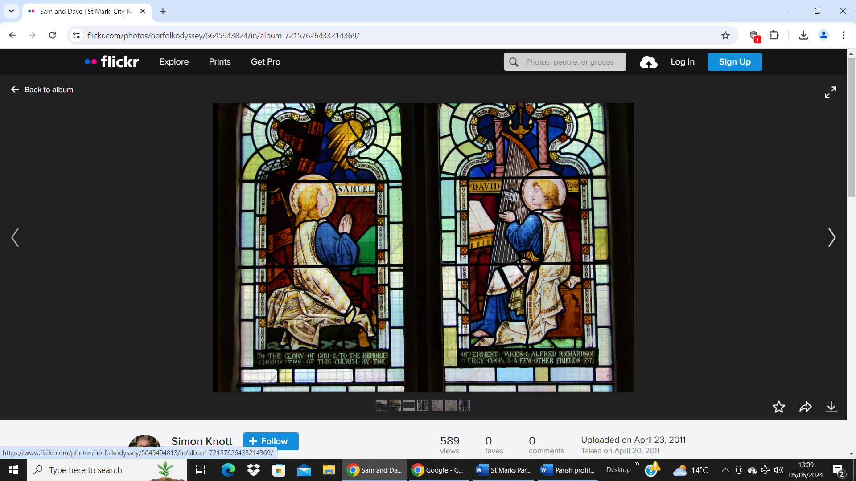  The vestry window depicting Samuel and David | 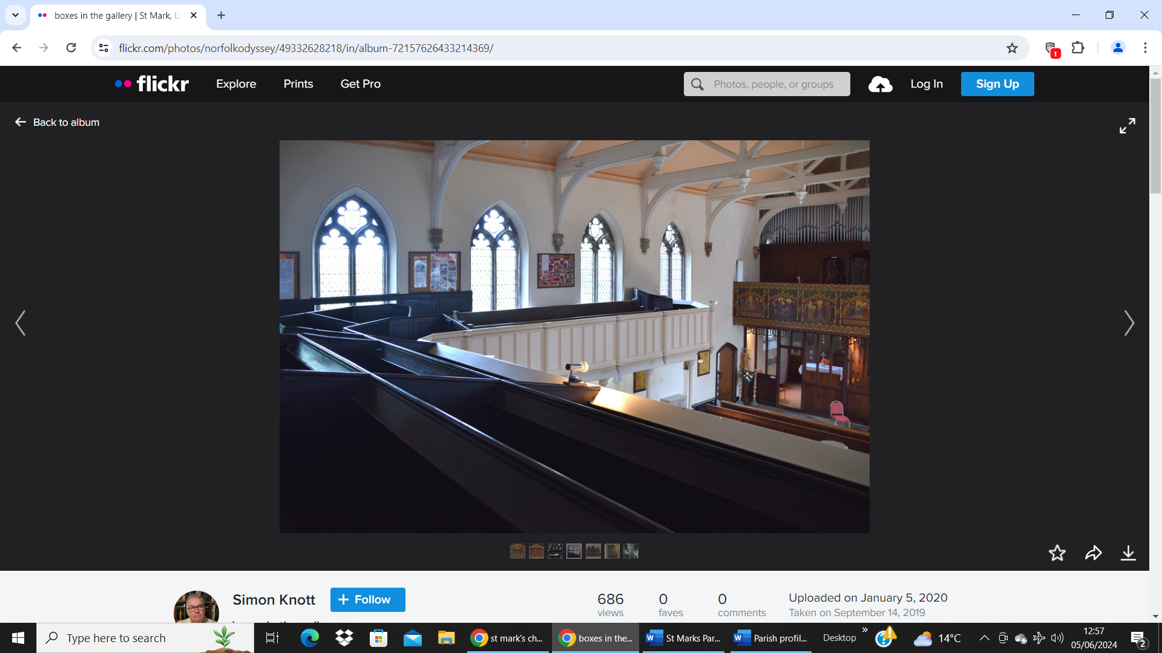  The 19th century box pews in the gallery  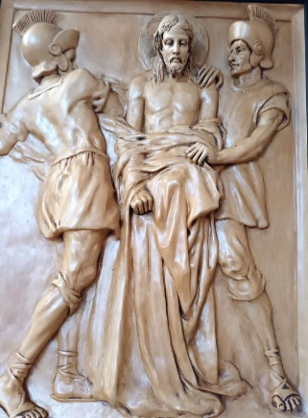  Detail from the Stations of the Cross  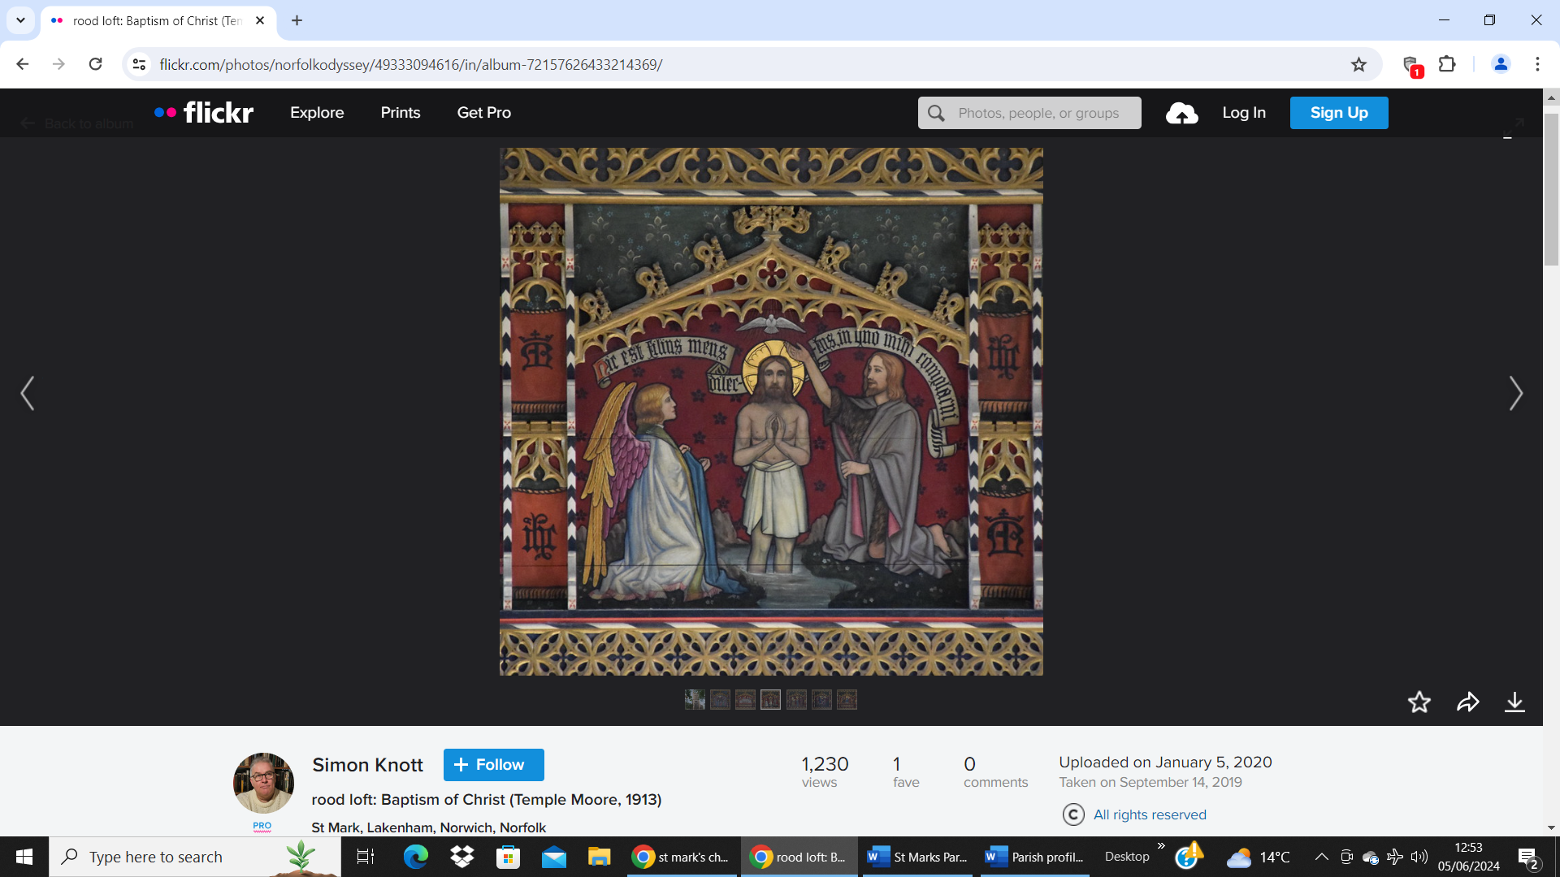  Detail from the rood screen by Temple Moore  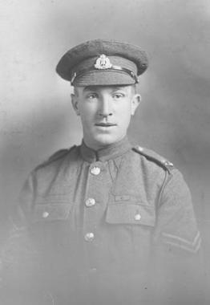  Sidney James Day VC

- 13 -
The Vicarage
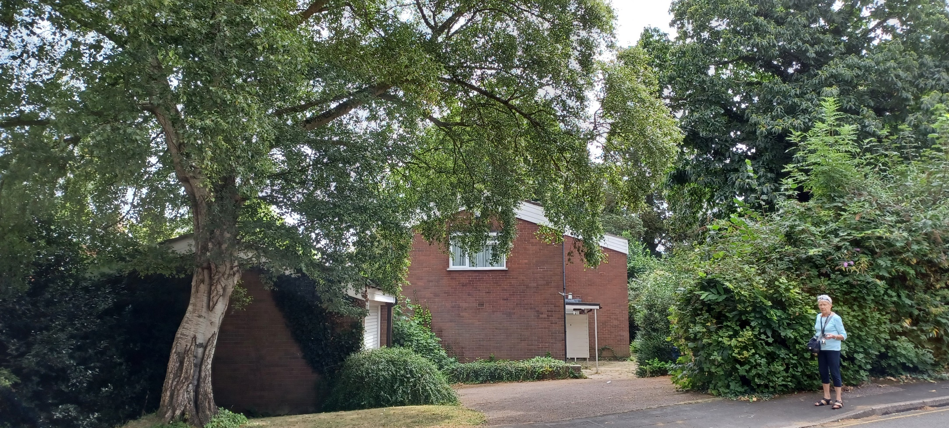
St. Mark’s Vicarage is situated in Conesford Drive, a tranquil cul-de-sac just off Bracondale, and lying within the Bracondale Conservation Area. Owned by the Diocese, the vicarage is approximately a quarter of a mile from St. Mark’s Church; around a mile from the city centre to the north-west; and three quarters of a mile from the railway station to the north. The extensive detached property offers ample family accommodation as follows:

Ground floor: Long entrance hall; large lounge & dining area; kitchen & utility area; office/study.
First floor: Landing; 5 bedrooms (1 en-suite); bathroom (with bath & shower); boiler cupboard.
Curtilage: Large detached garage; paved open/parking area; enclosed rear garden.

Bracondale Residents’ Association  The Association exists to preserve the special character of the neighbourhood and to foster communication between its residents. It promotes research into the local history and natural history of the area and liaises on behalf of its members with the local councils etc. on proposed changes and local issues. The Association has lively history and gardening groups. There is a book group, and some members take an active role in litter picking and gardening in public areas. Members’ events include lectures, walks, coffee mornings and parties. Since 2020 a shopping service for the elderly and housebound has been operated. | 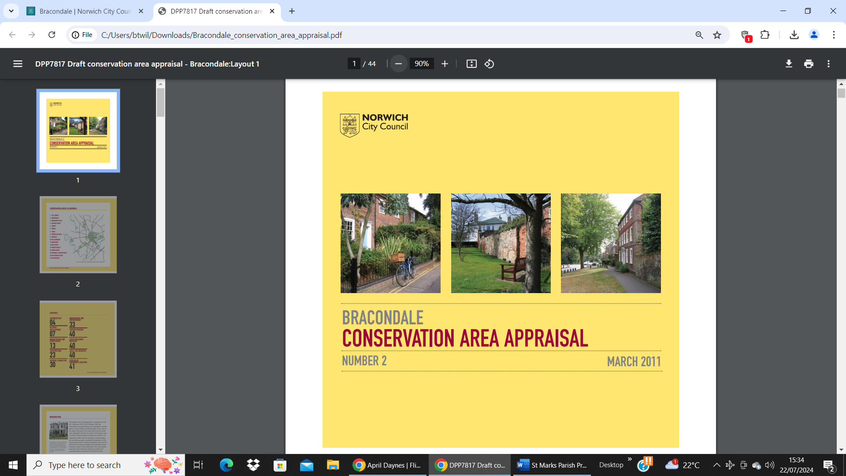

- 14 -
Finances
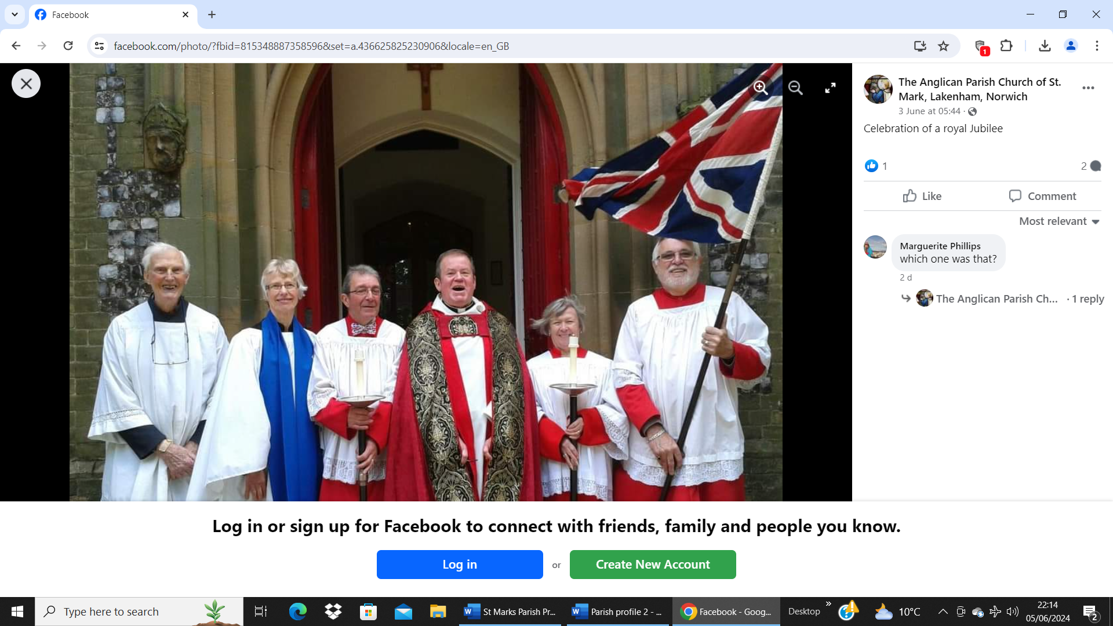
The copy accounts in Appendix 3 show the very healthy state of the parish’s finances with several hundred thousand pounds in the bank.

St. Mark’s owes a huge debt of gratitude to the late Alan Huggins (left), a loyal servant of the church from the age of 4 until his recent death in his 90s, who left his whole estate to the church to fulfil his wish that St Mark’s will be able to serve this parish for many years to come. Since his passing, Alan’s kindness and generosity have helped to support various initiatives for the benefit of churchgoers and also the wider Lakenham community. These have ranged from low-key projects, like providing new attractive notice boards, to major works involving the installation of a completely new lighting system in the church to enable special features and characteristics to be highlighted and displayed in a more atmospheric and dramatic way. Additionally, the respective approach drives up to the church from City Road to the east and from Hall Road to the west have been completely re-surfaced along with the footpaths skirting the outside of the church. As muddy, pot-holed tracks, these had previously been difficult to negotiate in bad weather, so the improvement has been significant with the new improved surface.
The Alan Huggins Legacy

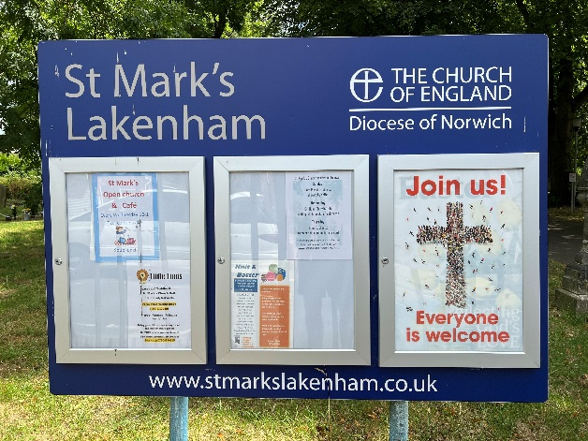  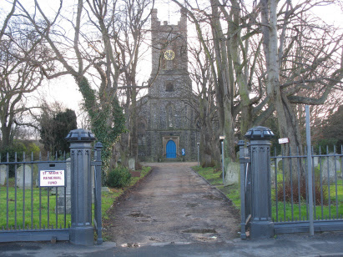 | 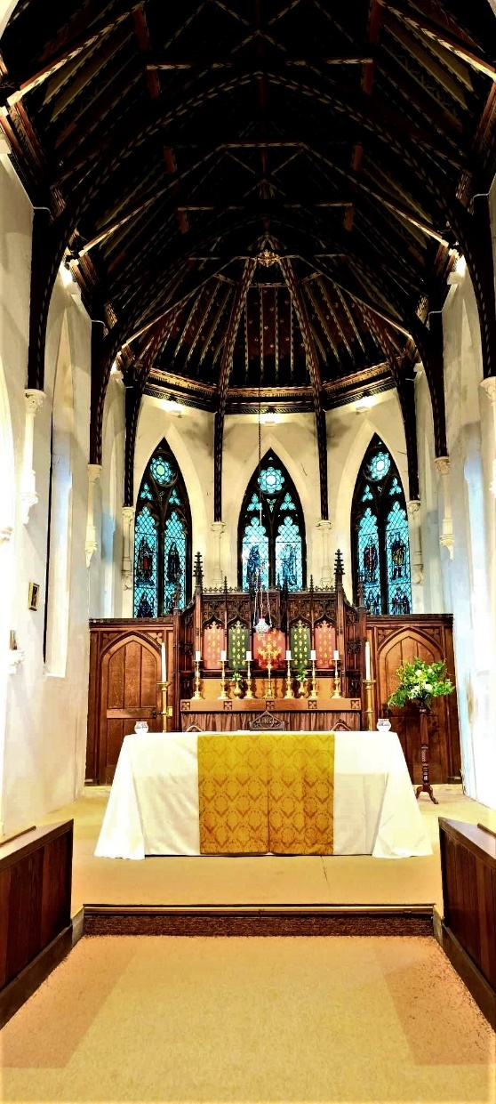

- 15 -
Safeguarding, Racial Justice and Inclusion

Safeguarding
Our parish of Lakenham St. Mark is committed to safeguarding children, young people and adults from harm. We follow the House of Bishops guidance and policies and have our own Parish Safeguarding Officer (PSO).
The Parish Safeguarding Policy is set out in Appendix 4 on page 24.
If anyone has safeguarding concerns at St. Mark’s please contact Marguerite Phillips our Parish Safeguarding Officer on 01603 452942 or the Diocesan Safeguarding Team at safeguarding@dioceseofnorwich.org.  If you have immediate concerns about the safety of someone, please contact the police and your local authority’s children or adult social care services. | 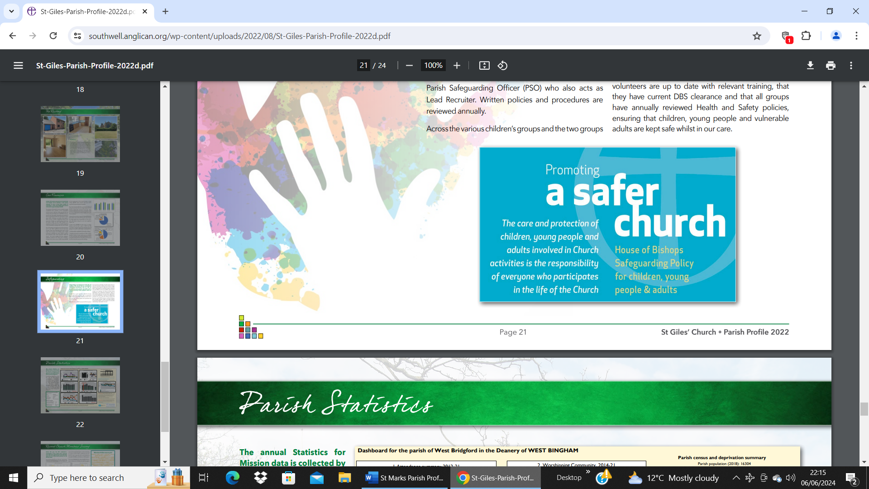

Racial Justice and Inclusion

We believe we are all one in Christ. All manifestations of racism or discrimination of any kind are wholly unacceptable, and contrary to his teaching. We have identified the inclusion of people from black and minority ethnic backgrounds as an essential part of our mission.

Lakenham St. Mark takes all forms of exclusion very seriously. Over the years, the church has worked to address a range of issues. Racial Justice and Inclusion is a challenge currently facing organisations as an urgent priority throughout the UK. We feel it is our Christian calling to meet this challenge to the very best of our ability.
Individually and collectively, we will be responsible for building racial equality awareness; embedding equality in our processes; broadening participation in the work of Lakenham St. Mark; and enhancing belonging and service for everyone within the worship and community of St. Mark’s. | 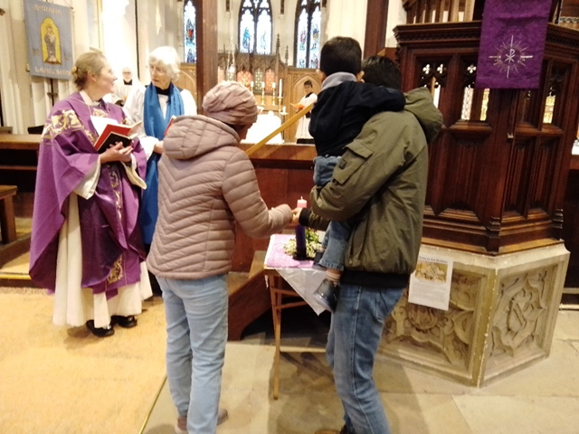  One of our families lighting Advent candles

- 16 –
Living and working in Norwich and Norfolk

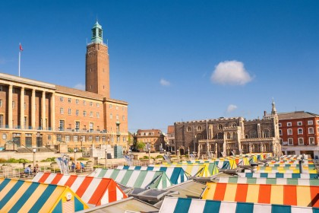  Norwich City Hall, medieval Guildhall and market | 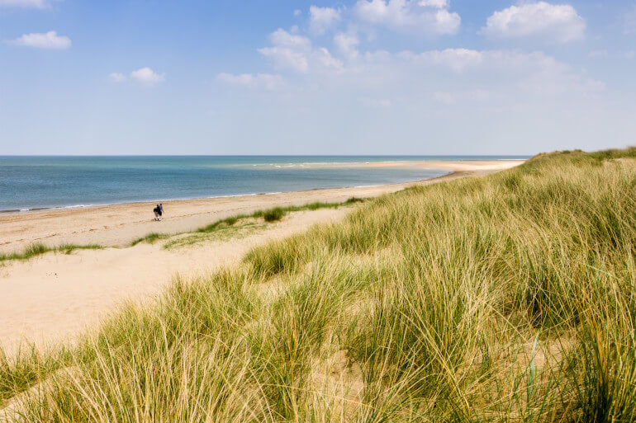  The Norfolk Coast Path stretches for 83 miles

In December 2023, Norwich was rated as the best UK city in which to live and work by the onefamily website based on quality-of-life factors. It was also rated fifth in the list of happiest cities. It was the first UK city to be designated as a UNESCO City of Literature and is home to the National Centre for Writing.

Norwich was England’s second city after London until the 18th Century and has the largest collection of medieval churches in northern Europe. Amongst its other accolades are the UK’s first provincial newspaper, the first provincial theatre, and the first English public library. Famous historical figures with Norwich associations include Boudica, Julian of Norwich, Lord Nelson, Elizabeth Fry, Anna Sewell and Edith Cavell.

The greater Norwich area now has an estimated population of just over 210,000 with a mix of businesses from sectors including creative and digital industries, professional services, health and life sciences, and energy and environmental organisations. Norwich Research Park is one of the largest single-site concentrations of research in food, geonomics and health in Europe; it is home to four world-leading research institutes, a teaching hospital, and the University of East Anglia which was ranked 26th out of 131 in “The Times” 2024 list of UK universities. In the city centre, Norwich University of the Arts has established a national reputation as an innovative and creative community in arts, design and media education for more than 175 years.

The city is a hub for finance and insurance and, with a diverse ‘high street’, retail is booming; the central Norwich Market was named the best outdoor market in Britain in 2019. Culturally the city is of regional importance with its rich offering of museums and theatres. There are many excellent parks, a network of cycleways and other recreational facilities. Championship football can be seen at Norwich’s Carrow Road stadium. As an important East of England tourist destination, Norwich has a very compact and walkable historic core that features the Cathedral Quarter, the Castle Quarter, the Writers’ Quarter and Norwich Lanes amongst others.

Norwich has fast and regular rail links with London as well as other services to the midlands and beyond. Norwich International Airport offers scheduled flights to UK and European destinations as well as holiday flights to Greece, Cyprus, Spain and Turkey. Outside Norwich itself, Norfolk is a county of great topographical diversity with the North Norfolk Coast Area of Outstanding Natural Beauty, the Broads National Park, the forests of Breckland, and the flat wide-open landscapes and big skies of the Fens.

- 17 -
APPENDIX 1
Parish boundary, statistics & demographics

Boundary of St. Mark Lakenham Parish:
The parish boundary (as of January 2022) is delineated in blue on the image below:

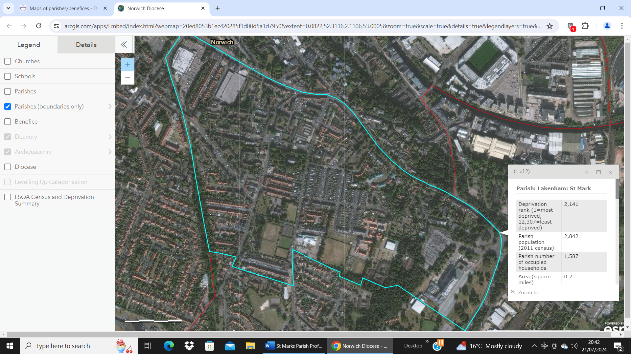

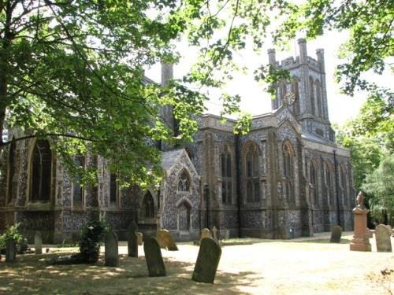  St. Mark’s Church, Lakenham | 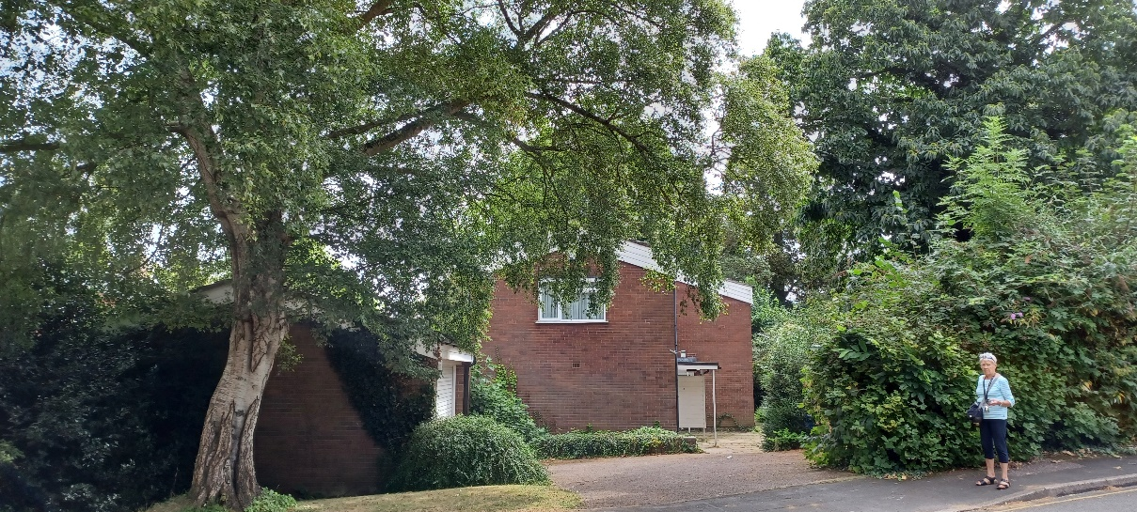  St. Mark’s Vicarage, Conesford Drive, Lakenham
- 18 -
Parish statistics and demographics:

The following parish data for St. Mark, Lakenham are based on information available from the Diocese of Norwich website. Please refer to that website (address below) for a detailed list of data sources, qualifications and supplementary information:
https://www.dioceseofnorwich.org/parish-support/parish_support-parish_data_forms_statistics__maps/parish_support-parish_data_forms_statistics__maps-maps_of_parishes-benefices/

For more information, see the Research and Statistics Unit web pages:
https://www.dioceseofnorwich.org/parish-support/parish_support-parish_data_forms_statistics__maps/parish_support-parish_data_forms_statistics__maps-maps_of_parishes-benefices/

Parish local name | Lakenham St. Mark |  | % aged 30-44 | 23.2
Parish legal name | St. Mark Lakenham |  | % aged 45-64 | 23.3
Parish code | 260090 |  | % aged 65 and over | 19.2
Benefice | Norwich, Lakenham Saint Mark |  | % White ethnicity | 89.7
Benefice ID | 26/299D |  | % Asian ethnicity | 5.45
Deanery | NORWICH (EAST) |  | % Black ethnicity | 1.2
Deanery ID | 26104 |  | % Mixed ethnicity | 2.8
Archdeaconary | NORWICH |  | % Other ethnicity | 0.8
Archdeaconary ID | 261 |  | % Christian | 45.0
Diocese | Norwich |  | % Buddhist | 0.8
Diocese | 26 |  | % Hindu | 1.9
Urban/Rural classification | Urban |  | % Jewish | 0.1
Deprivation rank (1=most deprived, 12,307=least deprived) | 2,141 |  | % Muslim | 2.2
Parish population (2011 census) | 2,842 |  | % Sikh | 0.1
Parish number of occupied households | 1,587 |  | % Other religion | 0.8
Area (square miles) | 0.2 |  | % No religion | 40.3
Population density (people per square mile) | 11,977 |  | % Religion not stated | 8.8
% aged 0-4 | 5.4 |  | Church Urban Fund poverty lookup tool | More info
% aged 5-17 | 7.8 |  | Parish population (2018 update) | 3,120
% aged 18-29 | 21.2

- 19 -
APPENDIX 2
Annual Report 2024

St. Mark Lakenham Parochial Church Council

Annual Report prepared for the APCM 2024

The Parochial Church Council is tasked with managing the Church’s affairs and
co-operating with the Incumbent to promote Ministry and Mission in the Parish

The Parochial Church Council met on five occasions in the past year. The supervision of the new light installation, churchyard security and maintenance, safeguarding concerns and training, Church Hall management, finance and Deanery Synod updates were among the topics covered by the Council.

Review of the year. It has been a full and varied year with many traditional activities now firmly back in the calendar. The new lighting was undoubtedly a significant development; after the chaos and mess of the installation period it was a real treat to see all our special features so well lit and to have excellent lighting for all our activities. A dedication service was held in July where the choir of Christ Church Eaton joined us for Festal Evensong. This was followed by a celebratory tea party. Thanks were expressed to Norwich Electrical, INTO THE FUTURE and the lighting consultant James Rackham who guided us through the whole process. The late Alan Huggins, whose generosity enabled it all, was also remembered.

One significant development has been a steady increase in our attendance numbers: several new friends have joined us. The overall attendance number for 2023 was 1,021 (2022 numbers were 862, with 732 for streamed services).

Little Lions has gone from strength to strength. Jessica Debbage competently leads the activity and uses creative energy and imagination to provide a wholesome and enjoyable activity; the attendance numbers are good, at times in the year almost at maximum capacity. Father Christmas made his annual visit and children with parents/carers had a festive gathering by the crib in church. The only drawback is that we could do with more volunteers to help make teas/coffees at Little Lions.

Knit ‘n Natter has met fortnightly under Helen Wilkinson’s leadership; this has also enjoyed good numbers, up to 18 per session. The group provides companiable fellowship and a welcome get-together.

Church Café and Open Church has continued with great success on Wednesdays. Hundreds of hot drinks and cakes (with thanks to Waitrose, Eaton for support in the early months) have been consumed and visitors come in large numbers. Many are new to St. Mark’s and some have joined the congregation in the process. A rota of volunteers help run things, with two on duty at any one time.

Music has also gone from strength to strength with David Uden providing much wonderful organ music and also guiding our singers to provide introits or anthems/motets for special occasions. A new setting of the Eucharist has been introduced.

- 20 –

Marguerite and Peter Philips and Sally West-Lindell have led congregational singing on the Sundays when David is not with us. A huge THANK YOU to organist and singers.

Worship and special occasions. Sunday services and festivals have been observed with colour, ceremonial and style. The new vestments add to the proceedings and it has been very good to have two new altar servers. A special Eucharist was celebrated with the theme of Coronation last May, Christmas Eve had a very lively and packed Family Carol service again, perhaps this year the roof really was raised! And the congregation in their exuberance ended the service with sustained applause. A spectacular Crib Festival was also staged in December. Another pre-Christmas Coffee morning was also held with special support for cancer care/support. Holy Week and Easter were kept with a full range of well-supported observances; among them Palm Sunday with ceremonies and a procession around the outside of the church, a Good Friday walk of witness, this time through the streets of the parish, and a special service with a sequence of music and readings on the Passion. We had one baptism and two members were confirmed. At the Candlemas service, Fr. Erik’s 25 years at St. Mark’s were celebrated with cake and wine. St. Mark’s once more participated in Heritage Days and the annual Sponsored Cycle Ride.

Our online presence has been maintained through achurchnearyou and our Facebook page. The latter has 200 followers, much information is shared and new posts appear regularly. Streamed services have been offered this year for festivals and special occasions only. As an interesting snapshot, here are some FB statistics: the photos from the recent Palm Sunday celebration were seen by 149 and the post from the Good Friday procession was seen by 89. Our streamed Christmas Carol service had 103 viewers, the online Good Friday service was seen by 59, the streamed Easter service by 79. Of our followers, 28.20% are men, 71.80% women, the age group with the highest “clicking” profile is 35-44. Apart from the UK we have viewers in India, Canada and Brazil!

As ever, we thank all who contribute to our life and the smooth running of everything. It has been a very rewarding and good year. The challenge will be to keep the momentum going, especially in the light of the approaching interregnum.
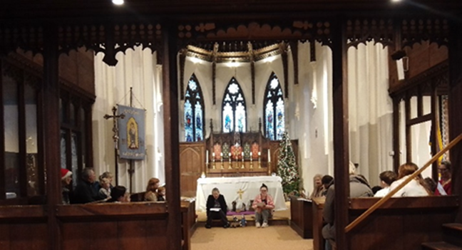
Little Lions Christmas Service

- 21 -
APPENDIX 3
Parish Accounts for 2023

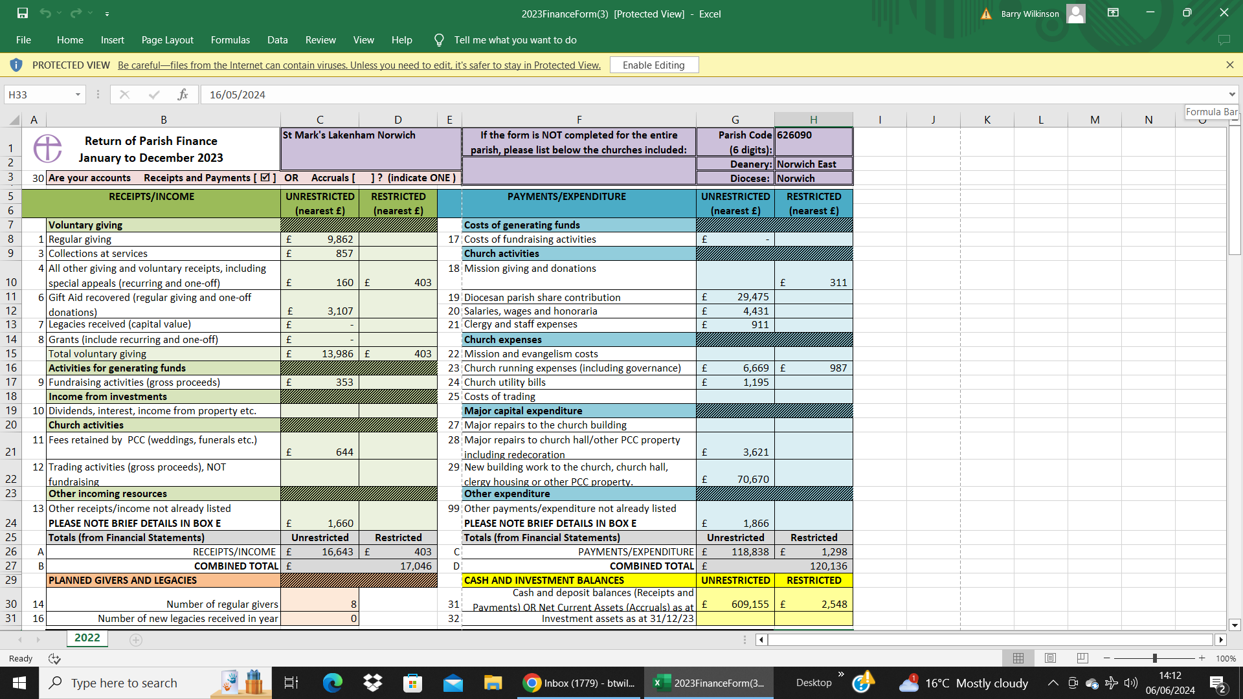
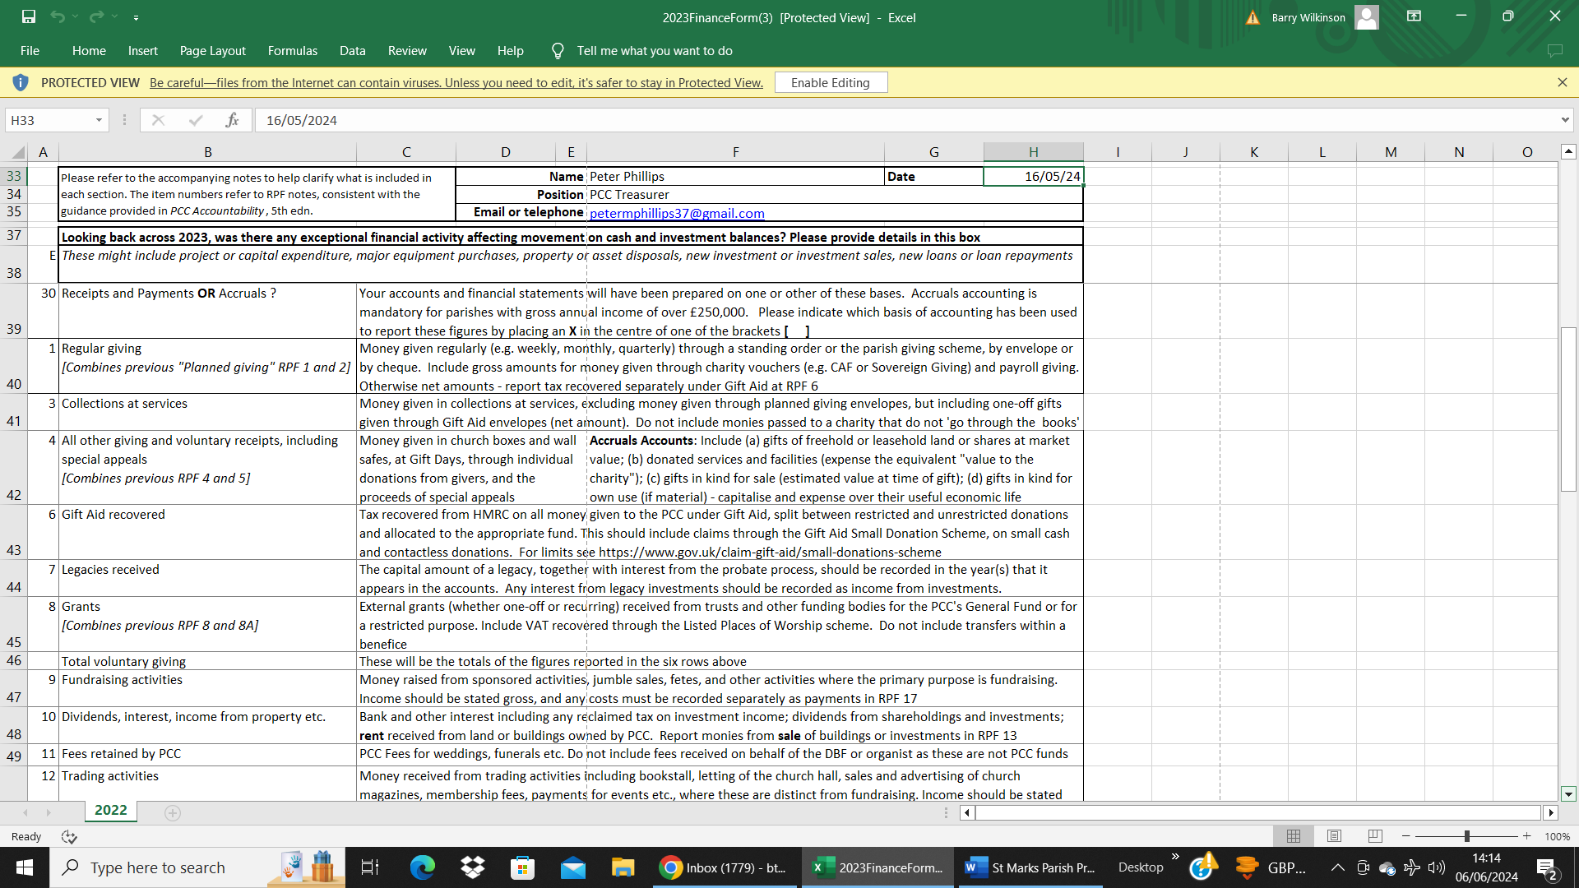

(Continued on page 22 ………………..)

- 22 –

(………………. Continued from page 21)

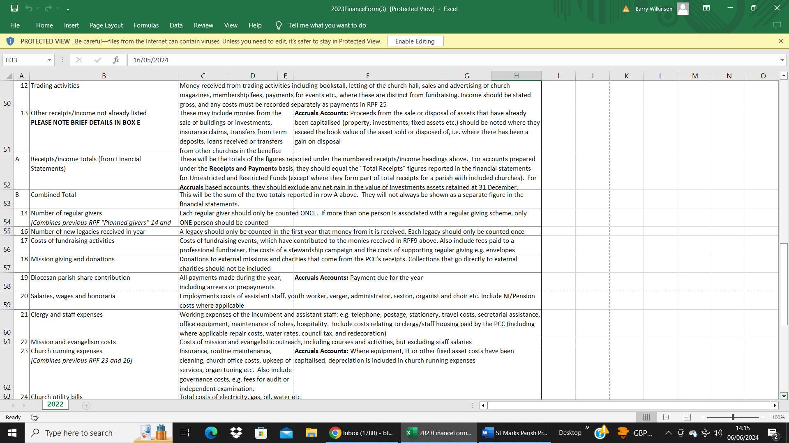
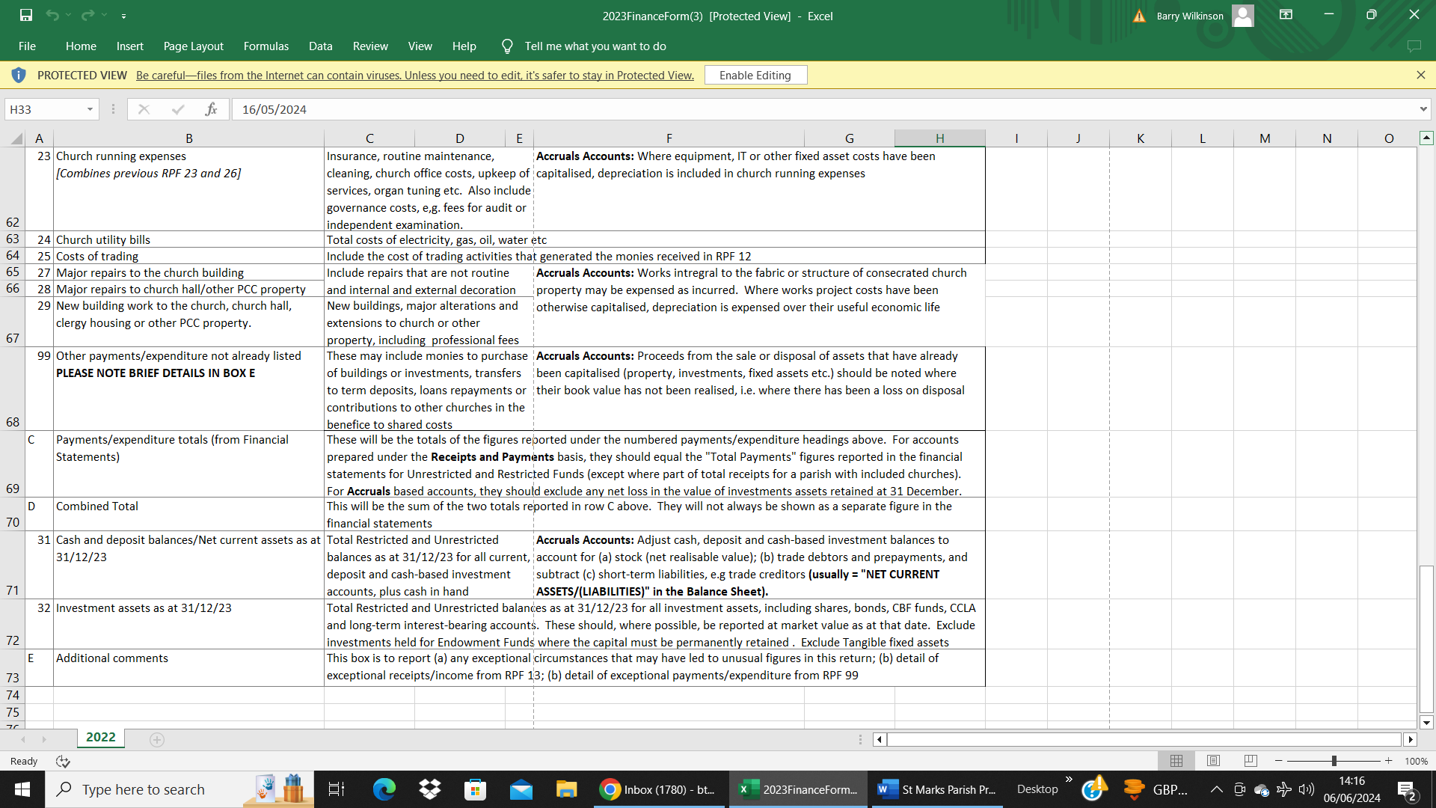

- 23 –
APPENDIX 4
Safeguarding Policy

The Church of England Diocese of Norwich
Parish of St. Mark Lakenham
Safeguarding Policy Promoting a Safer Church

The following policy was agreed at the Parochial Church Council (PCC) meeting on 15th October 2024.

In accordance with the Church of England Safeguarding Policy our church is committed to:

- Promoting a safer environment and culture.
- Safely recruiting and supporting all those with any responsibility related to children, young people and vulnerable adults within the church.
- Responding promptly to every safeguarding concern or allegation.
- Caring pastorally for victims/survivors of abuse and other affected persons.
- Caring pastorally for those who are the subject of concerns or allegations of abuse and other affected persons.
- Responding to those that may pose a present risk to others.

The Parish will:

- Create a safe and caring place for all.
- Have a named Parish Safeguarding Officer (PSO) to work with the incumbent and the PCC to implement policy and procedures.
- Safely recruit, train and support all those with any responsibility for children, young people and adults to have the confidence and skills to recognise and respond to abuse.
- Ensure that there is appropriate insurance cover for all activities involving children and adults undertaken in the name of the parish.
- Display in church premises and on the Parish website the details of who to contact if there are safeguarding concerns or support needs.
- Listen to and take seriously all those who disclose abuse.
- Take steps to protect children and adults when a safeguarding concern of any kind arises, following House of Bishops guidance, including notifying the Diocesan Safeguarding Adviser (DSA) and statutory agencies immediately.
- Offer support to victims/survivors of abuse regardless of the type of abuse, when or where it occurred.
- Care for and monitor any member of the church community who may pose a risk to children and adults whilst maintaining appropriate confidentiality and the safety of all parties.
- Ensure that health and safety policy, procedures and risk assessments are in place and that these are reviewed annually.
- Review the implementation of the Safeguarding Policy, Procedures and Practices at least annually.

Each person who works within this church community will agree to abide by this policy and the guidelines established by this church, the Parish Safeguarding Officer.

Parish Safeguarding Officer: | ……………………………………………………………………………………………………………………………………………..
PP the Incumbent: | ……………………………………………………………………………………………………………………………………………..
Churchwarden: | ……………………………………………………………………………………………………………………………………………..
Date: | ……………………………………………………………………………………………………………………………………………..

- 24 –
Further information & getting in touch

We really hope that you find this Parish Profile of interest and of use, and we look forward to hearing from you about our vacancy.  For further information or to make direct contact please refer to the details below:    https://www.facebook.com/groups/2086516598415853  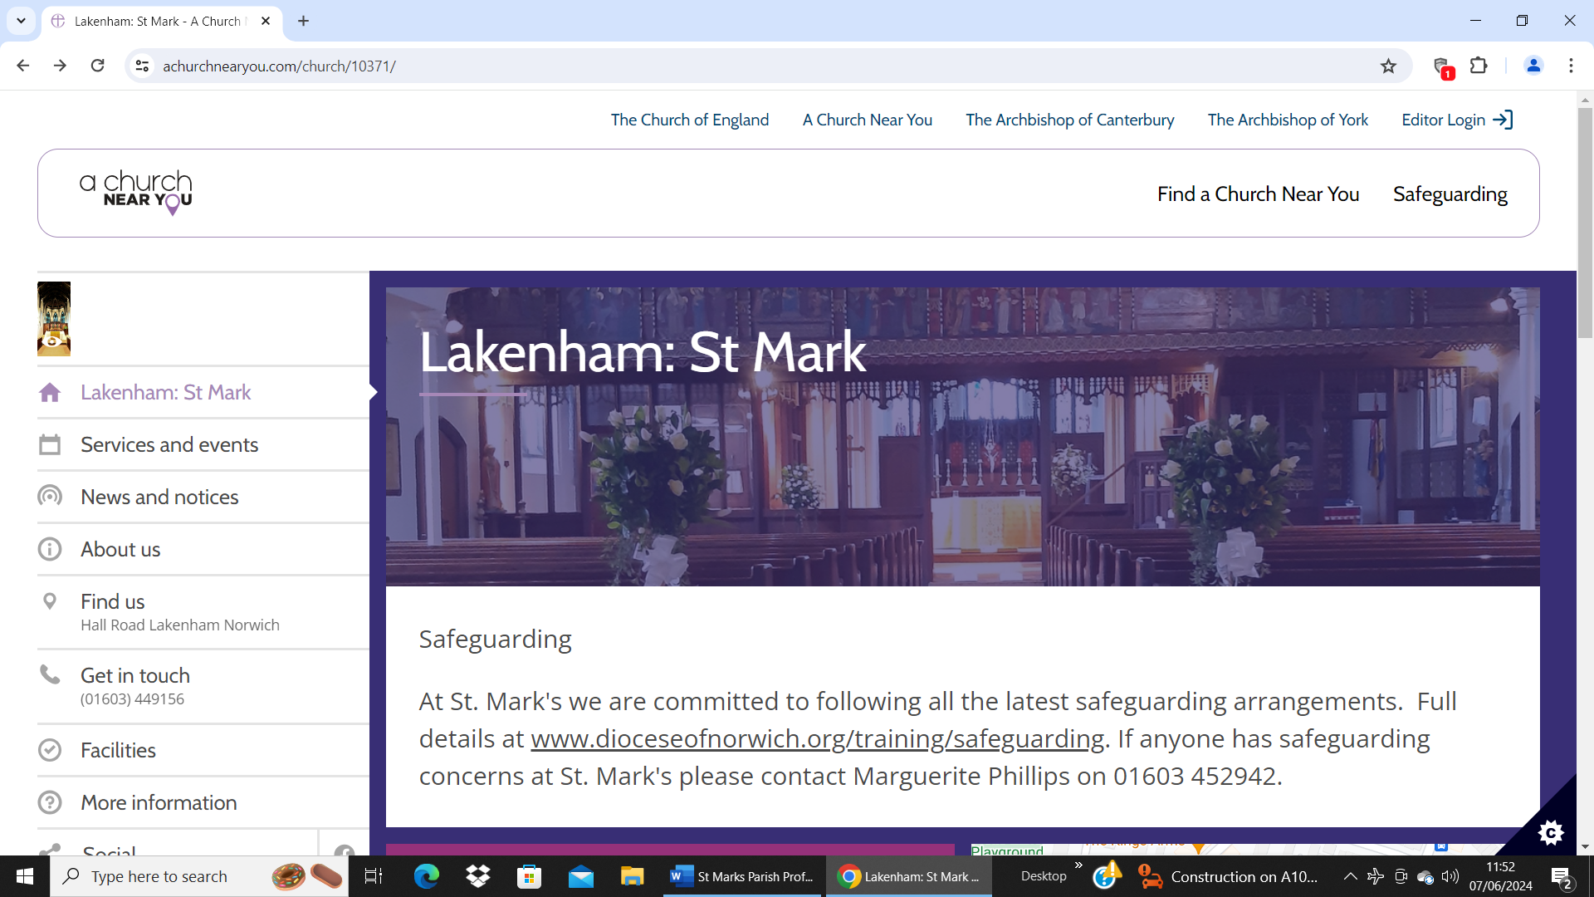  https://www.achurchnearyou.com/church/10371/  https://www.dioceseofnorwich.org/church/norwich-archdeaconry/norwich-east-deanery/lakenham-group-norwich-lakenham-st-mark-benefice/lakenham-st-mark-parish/st-mark/  Contact our Churchwarden:  Helen Wilkinson  Telephone: 07936 420668  Email: hmmwilkinson@hotmail.com | 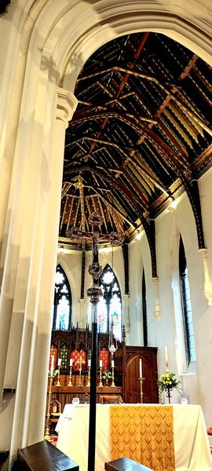

-25 –

This Parish Profile is published by
the Parochial Church Council

JANUARY 2025

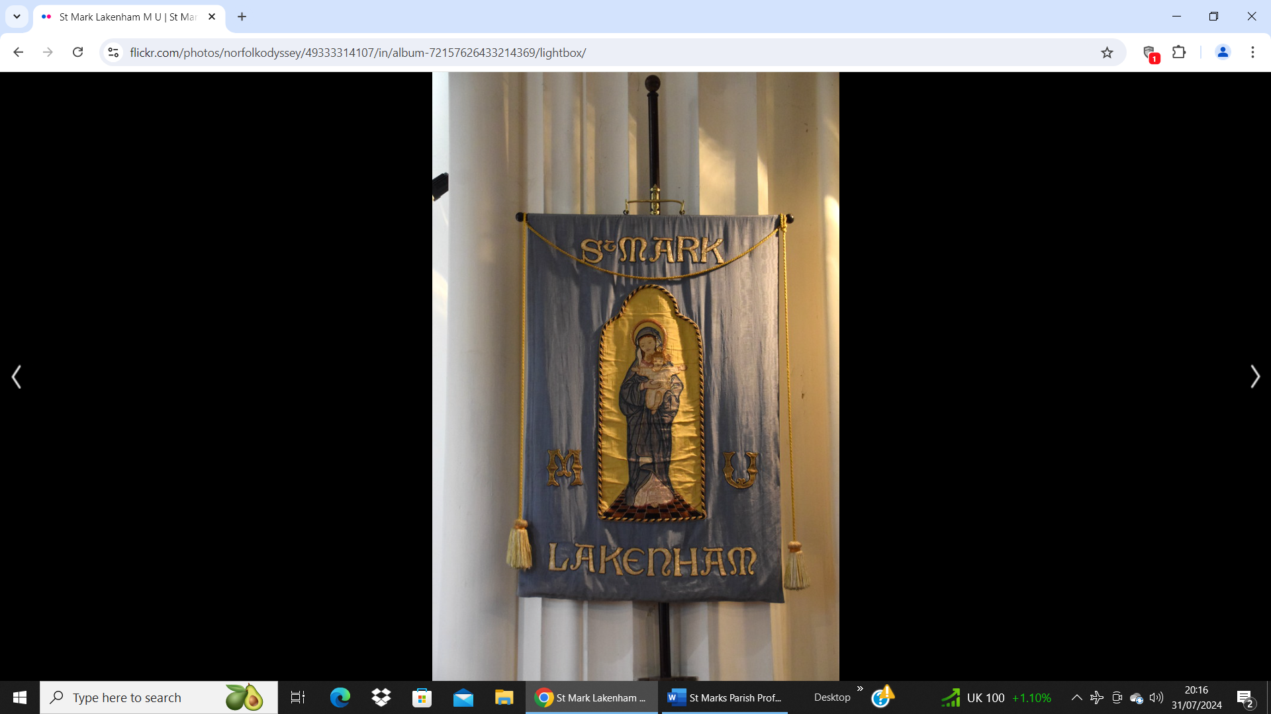

The Anglican Parish Church of St. Mark, Lakenham, Norwich
Hall Road
Norwich
NR1 3HL

Ordnance Survey Map Sheet TG20NW
Grid Reference TG 23423 07450

