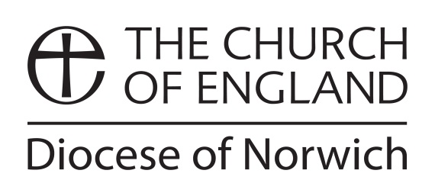

APPLICATION for a SABBATICAL

Before completing this form please save this document and re-name the document by inserting your name at the beginning of the file name, for example: Keith James SABBATICAL Application Form.doc

Please read the Diocesan Guidelines for Sabbaticals.

Discuss your plans with your Area Bishop or Archdeacon and consult with the CMD Officer before completing this form. [Feel free to expand (or contract) the spaces available for your responses.]

Name
Address
Telephone
Mobile
E-mail
Current post

The DBF now wishes to make all payments by BACS electronic transfer directly to nominated bank accounts so please would you fill in your account details:

Account Name
Account No
Sort Code

Current post

How long have you been in this post?
How long have you been in ordained\licensed ministry in this Diocese?
When were you ordained (or licensed as a lay worker)?
Have you had a Sabbatical before? If so, please give date(s) plus one-line description(s)

Proposed Sabbatical

What are the dates of your proposed Sabbatical?

Please describe the nature of your proposed Sabbatical:

What do you hope will be the outcome of the Sabbatical?

How will you report back about the Sabbatical, and to whom?
[NB: You will also need to provide a brief written report to the CMD Officer for Bishops and Archdeacons]

What arrangements will you make to cover your period of absence?

Costs and Funding

Please state the total anticipated cost of the Sabbatical and provide a (simple) breakdown of the budget.

Please state what Grants you are requesting from the Diocese. (If you are seeking funding or have received grants from other sources, please note that as well.)

Have you discussed these plans with your Area Bishop or Archdeacon?
Have you discussed these plans with your Churchwardens, ministerial colleagues and others who are directly affected by taking the Sabbatical?

Date

Please e-mail to:
Keith James, Archdeacon of Norwich and Continuing Ministerial Development Officer: archdeacon.norwich@dioceseofnorwich.org
and copy to:
Marleen Madinda, Ministry Team Administrator: marleen.madinda@dioceseofnorwich.org (v Jan 23)

The above information provided by you will be kept securely and shared only with the finance department of the diocese and will be kept for 6 years. https://www.dioceseofnorwich.org/privacy-policy/

